

**School of InfoComm Technology**

**Machine Learning**

Diploma in Data Science (DS)

Diploma in Information Technology (IT)

October 2023 Semester

**INDIVIDUAL ASSIGNMENT 1 REPORT**

(30% of Machine Learning Module)

**Deadline for Submission:**

**10th Dec 2023 (Sunday), 2359 Hours**

|  |  |  |
| --- | --- | --- |
| Student Name | : | Akul Arun |
| Student Number | : | S10243523 |
| Video Presentation Link | : | Done with Bongo |

**Penalty for late submission:**

10% of the marks will be deducted every day after the deadline.

**NO** submission will be accepted after 17th Dec 2023, 23:59.

Table of Contents

1. Introduction/ Overview 3

2. HR Analytics (Classification Problem) 4

2.1 Problem Understanding 4

2.2 Data Understanding 4

2.3 Univariate Analysis (Data Exploration) 6

2.3.1 Univariate Analysis of Categorical Variables 6

2.3.2 Univariate Analysis of Continuous Numerical Variables 8

2.3.3 Univariate Analysis of Discrete Numerical Variables 10

2.4 Bivariate Analysis (Data Exploration) 13

2.4.1 Bivariate Analysis of Categorical Variables with Target 13

2.4.2 Bivariate Analysis of Discrete Numerical Variables with Target 15

2.4.3 Bivariate Analysis of Continuous Numerical Variables with Target 17

2.3 Data Cleansing 19

2.3.1 Renaming Columns 19

2.3.2 Dropping Columns 19

2.3.3 Missing Data Imputation 21

2.4 Data Transformation 24

2.4.1 Categorical Encoding 24

2.4.2 Numerical Transformation 26

2.4.3 Handling Outliers 28

2.4.4 Scaling 29

2.4.5 Transformations that were not required 32

2.5 Correlation Analysis 32

2.6 Handling Target Variable Class Imbalance 33

3. AIRBNB (Regression Problem) 34

3.1 Problem Understanding 34

3.2 Data Understanding 34

3.3 Univariate Analysis (Data Exploration) 36

3.3.1 Univariate Analysis of Categorical Variables 36

3.3.2 Univariate Analysis of Numerical Variables 39

3.4 Bivariate Analysis (Data Exploration) 41

3.4.1 Number of Customers vs Price 41

3.4.2 Room Type vs Price 42

3.4.3 Room Type vs Availability 43

3.4.4 Geographical analysis of Customers 44

3.4.5 Geographical analysis of Price 44

3.4.6 Number of Host Listings vs Price 45

3.4.7 Demand vs Availability 45

3.5 Data Subsetting 46

3.6 Data Cleansing 48

3.6.1 Renaming Columns 48

3.6.2 Dropping Columns 48

3.7 Data Transformation 50

3.7.1 Categorical Encoding 50

3.7.2 Numerical Transformation 52

3.7.3 Scaling 54

3.8 Correlation Analysis 57

4. Summary & Further Improvements 59

4.1 Summary of HR Analytics Dataset 59

4.2 Future Improvements for HR Analytics problem 60

4.3 Summary of Airbnb Dataset 61

4.4 Future Improvements for Airbnb problem 61

# Introduction/ Overview

According to IBM, machine learning is a branch of artificial intelligence and computer science that focuses on the use of data and algorithms to imitate the way humans learn, gradually improving its accuracy. The goal of machine learning is to teach computers how to learn with explicit programming. Data is the key driving factor used to train algorithms to recognize trends and anticipate outcomes.

That brings me to the applications of machine learning; machine learning is used for making predictions and in recent years, the application for machine learning has branched out to aid fraud detection image recognition, etc.

However, now, we will be focusing on utilizing machine learning to make predictions for two separate scenarios. The first scenario deals with human resource management and the model predicts the employee who should be promoted. This would be helpful for the executives of the company to promote people as they spend less time shortlisting a group of people to promote as the algorithm does that within minutes.

The second scenario deals with Airbnb prices and the model will predict the rental price of listed Airbnb properties. This will be beneficial for a variety of the stakeholders including hosts and clients and presents them with different benefits. For hosts, they can find out the best prices to set for their listings to remain competitive and for customers, they will be able to find the best Airbnb deals ahead of time.

However, machine learning comes in many different forms and in this context, different types of machine learning have to be used depending on the type of problem and the dataset. For example, for the first scenario in our case, it is a binary classification problem because the target variable is discrete with two categories, promoted or not promoted and the model will be predicting one of these 2 categories.

However, for the second scenario, it is a linear regression problem because the target variable is the price which is a continuous variable and there is no fixed number of categories the model can predict from.

The focus of this assignment is to take a deeper dive into understanding the datasets, applying data cleaning and data transformations to prepare the data for the model building which will be the next part of the module.

For data-driven projects, the initial stage of comprehending, cleansing, and transforming raw datasets is essential. To guarantee integrity and dependability, datasets that come from a variety of sources are cleaned, which paves the way for precise model training. Data exploration is conducted to better understand the transformations required for the specific dataset. Transformation handles variables and outliers, ensuring effective pattern learning for enhanced predictive capabilities. Furthermore, transformation is necessary to convert string-type variables into numerical as some machine learning algorithms only accept numbers.

This initial stage of preparation is crucial because it produces a clear, organized, and representative dataset that serves as a solid basis for developing and testing machine learning models, which in turn affects the ultimate accuracy and resilience.

# HR Analytics (Classification Problem)

In this section of the report, I will be sharing more about the insights I have drawn from the data exploration of the HR dataset and also the reasoning behind the data transformations.

## Problem Understanding

The binary classification problem involves predicting employee promotions in an HR dataset. The goal is to accurately distinguish between those likely to be promoted and those who aren't. Key features influencing promotions will be identified, aiding in HR decision-making for talent management and organizational growth.

## Data Understanding

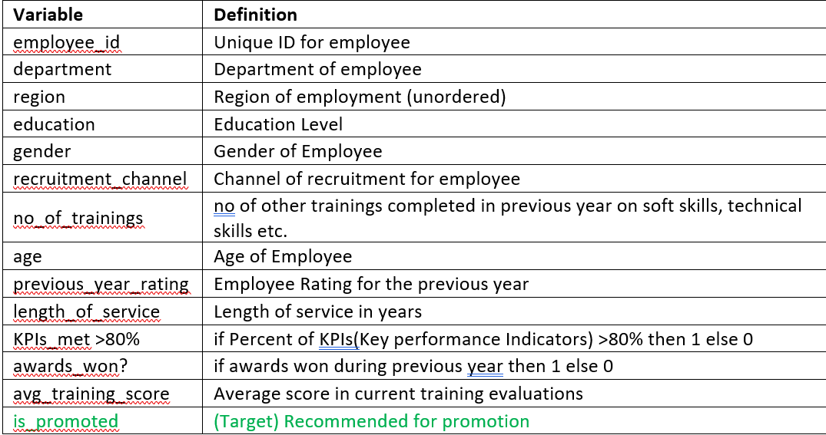

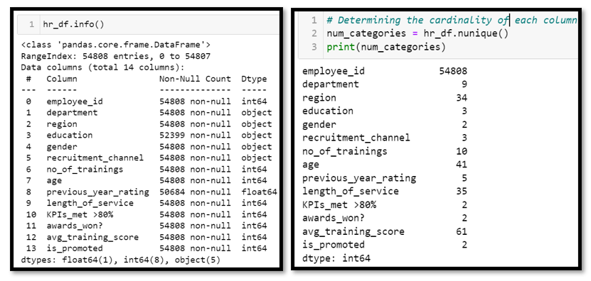

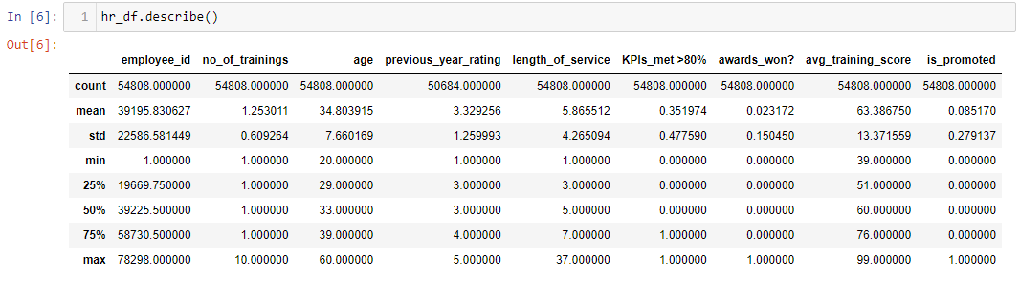

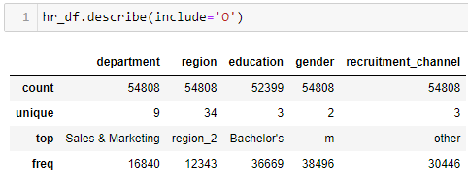

From this, I had a better understanding of the data values, data types of the variables, number of null values and the cardinality of the variables. Now that I knew which columns had null values, I could focus on these columns later on to try to find patterns to fill these null values. After knowing the data type and cardinality of the numerical features, I have a better idea of the variables to treat as categorical and which numerical variables to treat as discrete or continuous. It is better to treat numerical variables with low cardinality such as ‘previous_year_rating’ and awards_won? as discrete as these variables do not have a meaningful distribution.

## 2.3 Univariate Analysis (Data Exploration)

Next, I moved on to understand each of the variables from an individual standpoint. There is a narrower focus on each variable, aiding in understanding the distributions and patterns within the variable. In the context of this HR dataset, I will be finding more information of the patterns of the number of employees across each variable.

## 2.3.1 Univariate Analysis of Categorical Variables

**Department**

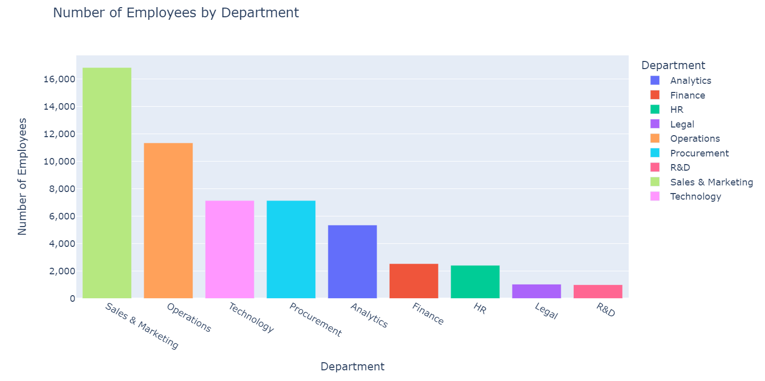

This chart gives me a deeper understanding of the operations of the company. We can understand that the company puts most of its efforts into sales and marketing as most of the company hires are from the sales and marketing department.

**Region**

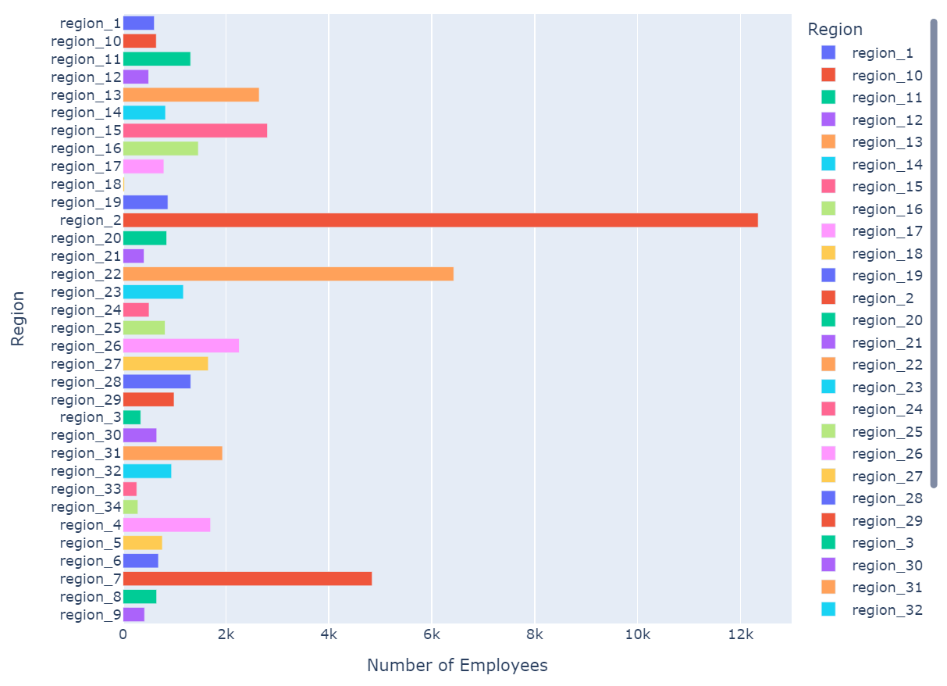

I used a horizontal bar chart to visualize the distribution of the employees across the regions due to the high number regions. We can see that region 2 has a significantly higher number of employees than the other regions and this might mean the main headquarters is in region 2.

**Education Level**

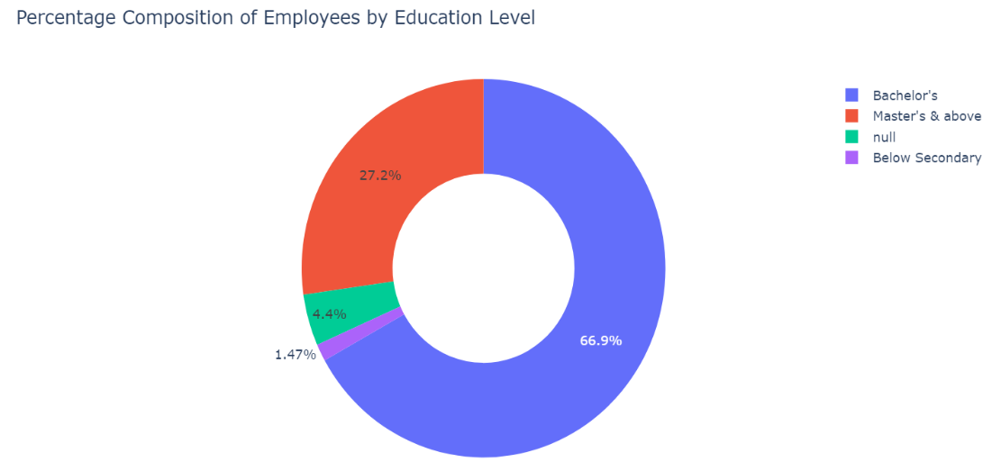

I found out more about the recruitment requirements of the company by looking at the education level composition of the employees. It is likely that this company mostly hires university graduates as more than 90% of its employees are university graduates.

**Gender**

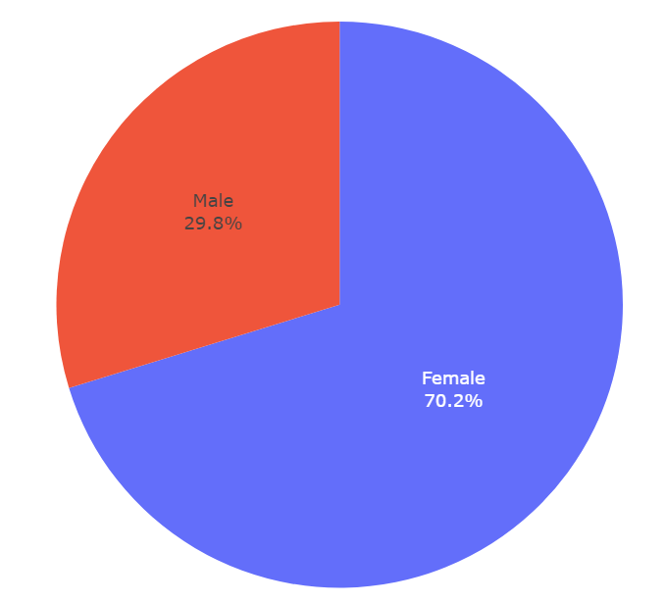

Even though there are generally more males than females in the working force, in this company more than 70% of employees are females. I have a clearer idea on the hiring strategies of this company now and since, the company heavily prioritizes sales and marketing, it will be hiring more women.

**Recruitment Channel**

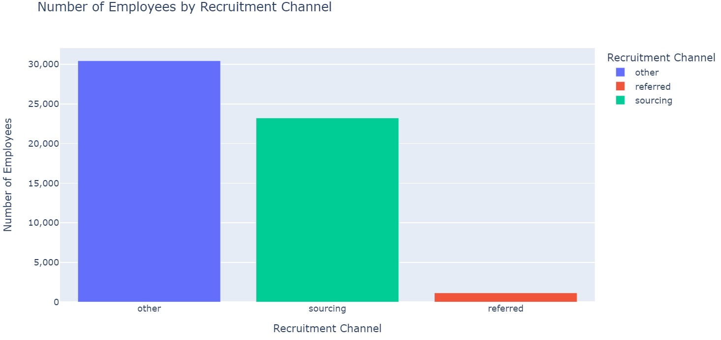

The recruitment channel also allowed me to understand the hiring strategies of the company in greater detail as I found out the methods the company uses to hire and we can see that very few employees get hired from referees which might mean that most employees are hired through qualifications and merit.

In summary, the univariate analysis of the categorical variables has allowed me to have a better understanding of the employee demographics, the company operations and the hiring requirements and strategies of the company.

## 2.3.2 Univariate Analysis of Continuous Numerical Variables

**Age**

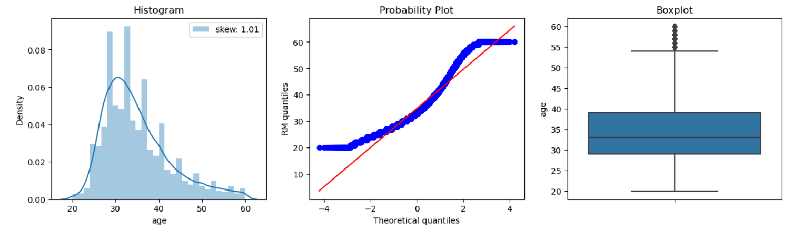

Most employees are around 30 years old and there are lesser older people. That is why the distribution of the variable is not normal and is right skewed. There are also some outliers present and these employees are the oldest ones between 55 and 60.

**Length of Service**

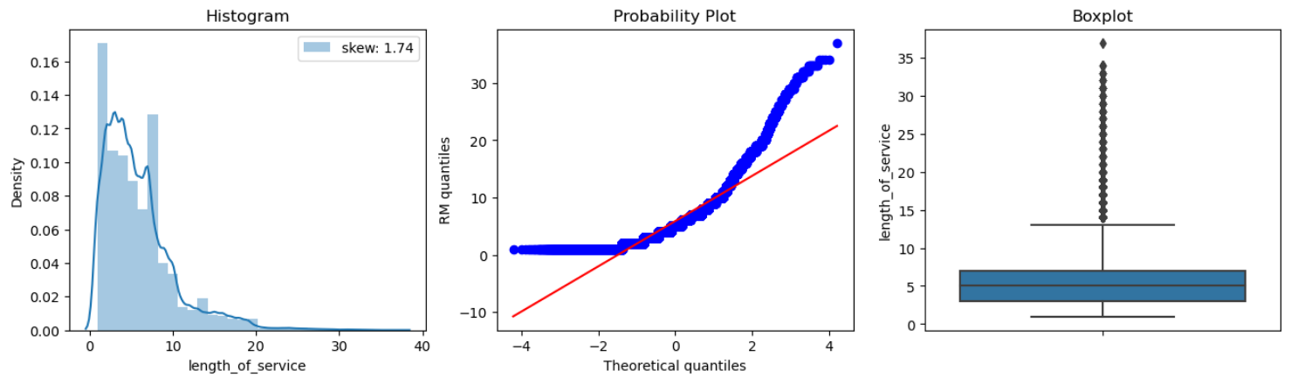

I have a better understanding of the company retention rate by looking at the length of service distribution of the employees and we can see that most employees work at the company for a short while only, less than 10 years which is why the distribution is extremely skewed to the right. This resulted in employees at the company for more than 15 years being outliers.

**Average Training Score**

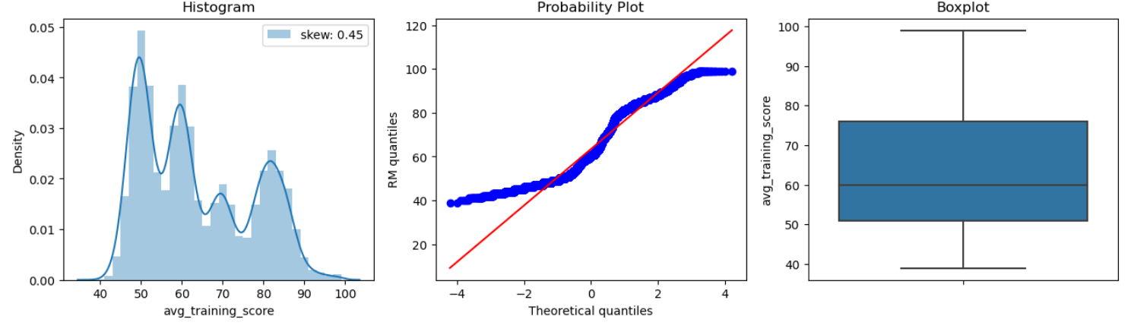

The distribution is not normal and is slightly right skewed as many employees have been scoring badly but there are also quite a number of employees scoring well. There are no outliers present in the average training score so no employee is doing incredibly well or extremely badly.

In summary, I have a better idea of the numerical transformations and outlier removal that need to be done.

## 2.3.3 Univariate Analysis of Discrete Numerical Variables

**Number of Trainings**

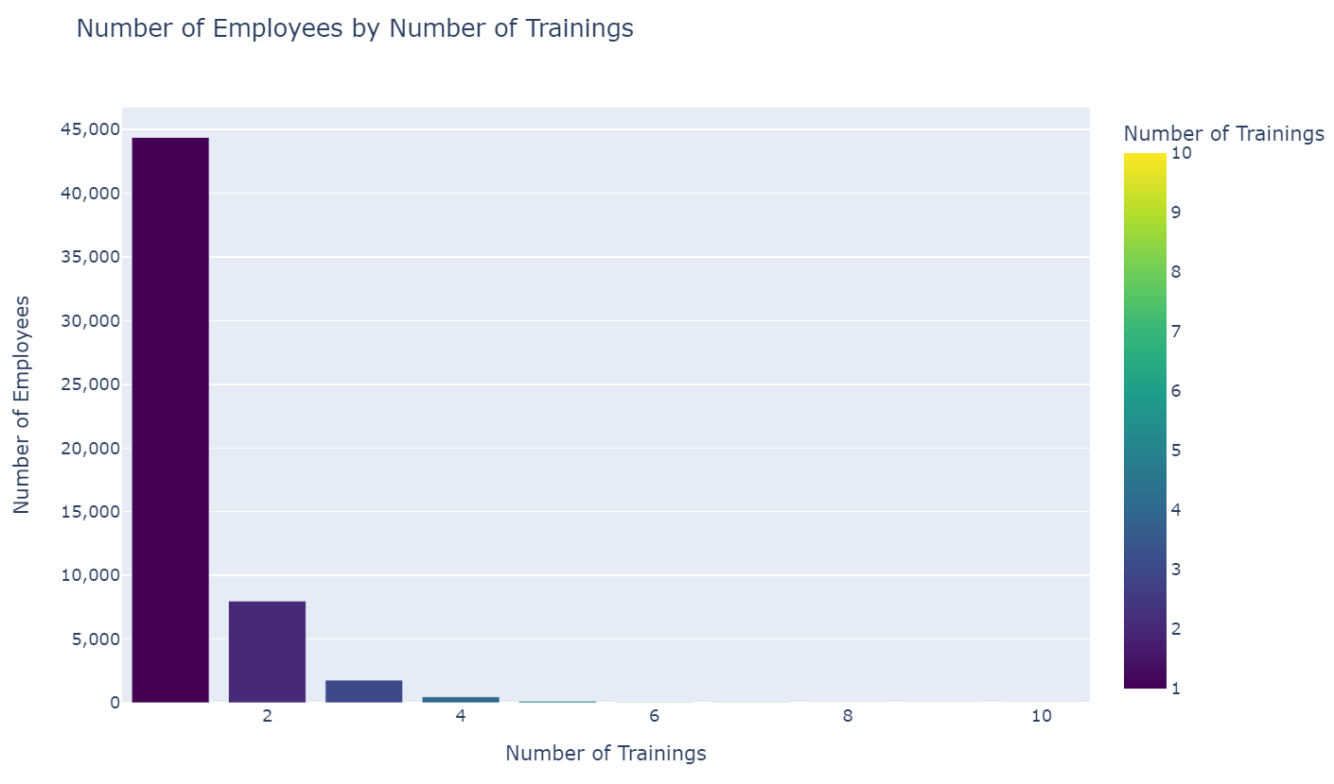

The number of trainings given to employees indicate upskilling opportunities for the employees and training gaps. Most employees are given very few trainings in the company so there is very little employee development happening in the company which can decrease promotion rates.

**Previous Year Rating**

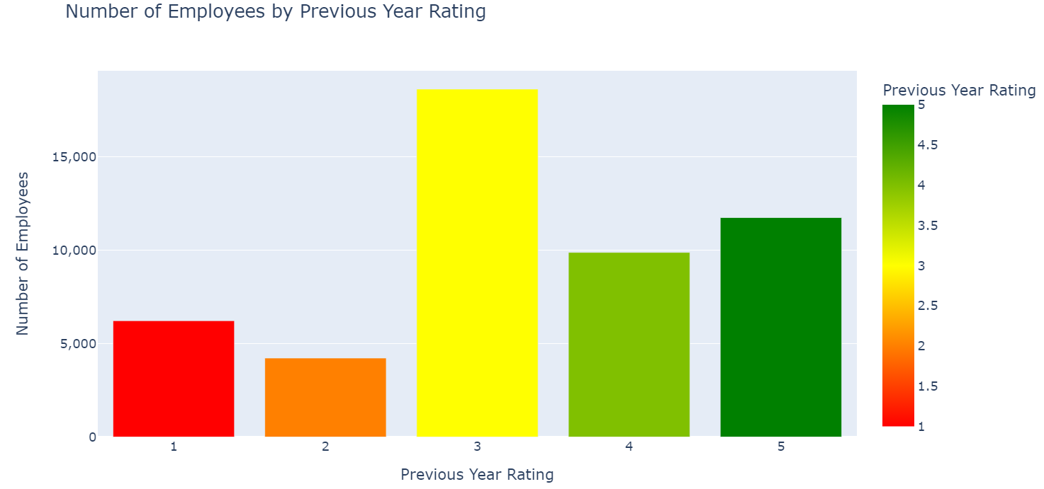

The previous year rating allows me to have a better general understanding of the employee performance. Most employees having had average performance and previous year rating can also affect the chances employees are promoted as higher ratings would increase the chances of promotion.

**KPIs met >80%**

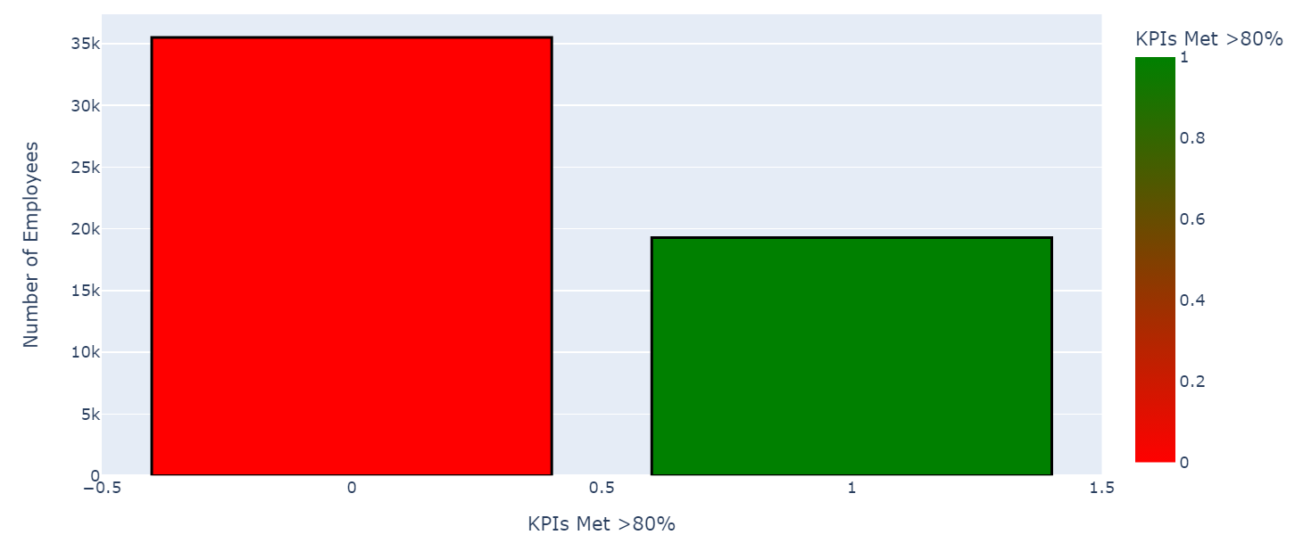

KPI stands for key performance indicator and it is another metric to assess employee performance. Less than half of employees are performing well and meeting KPIs above 80%, which might lead to lower promotion rates.

**Award won?**

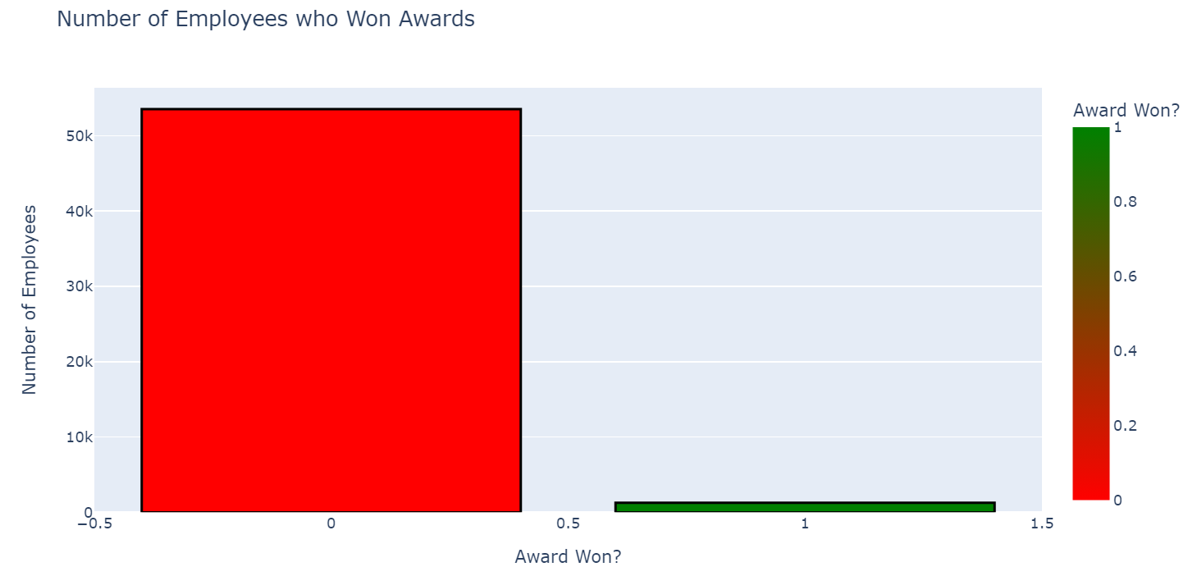

Awards is also another key factor affecting promotions as it distinguishes deserving employees. From the chart, we can see that an extremely low percentage of employees receive awards which might mean that the company might have high standards to give awards.

**Is Promoted (Target)**

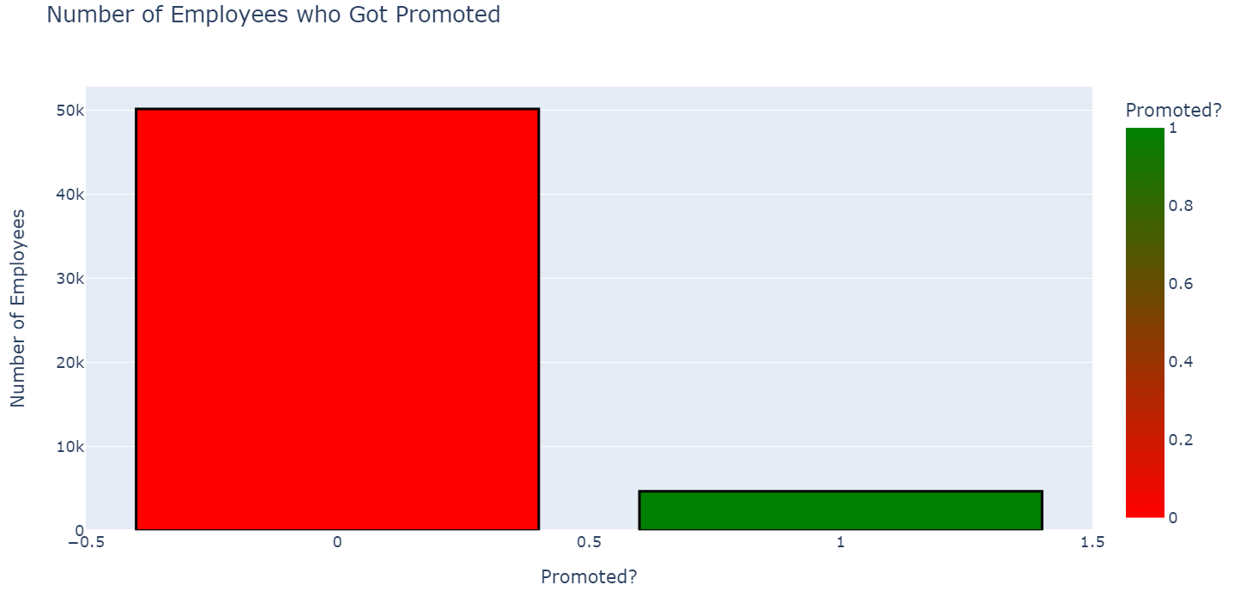

This column shows the number of employees who were promoted in the previous year and we can see that we do not have equal-sized samples for the two classes. As a target variable, this is not good as this lead to bias and poor predictions.

In summary, I have gained a better understanding of employee performance and have discovered the class imbalance in the target variable. I also have a better understanding of whether scaling and normalization is necessary for data transformation.

## 2.4 Bivariate Analysis (Data Exploration)

Next, I moved on to bivariate analysis where I analyzed the relationship of the different variables and the target variable and how the other variables affected each other. This would help me further understand the relevance of my variables with the target variable and identify the useful variables.

## 2.4.1 Bivariate Analysis of Categorical Variables with Target

**Department vs is_promoted**

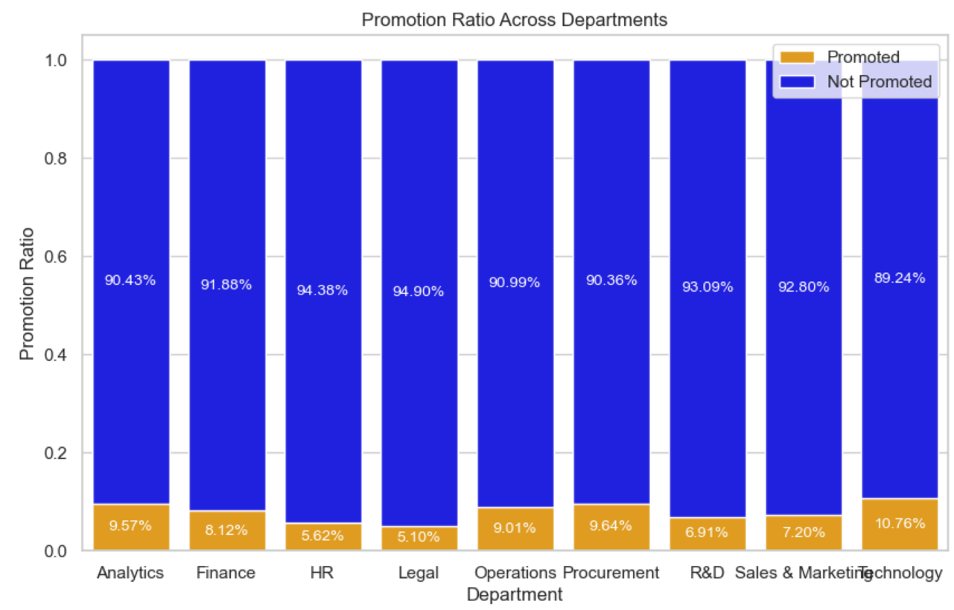

Different departments may have different promotion rates due to differing department performance and from the above, we can see that the technology department has the highest rates with many other departments close behind. Different departments may require different skill levels and technology might require the highest skill level which is why it has high promotion rates.

**Region vs is_promoted**

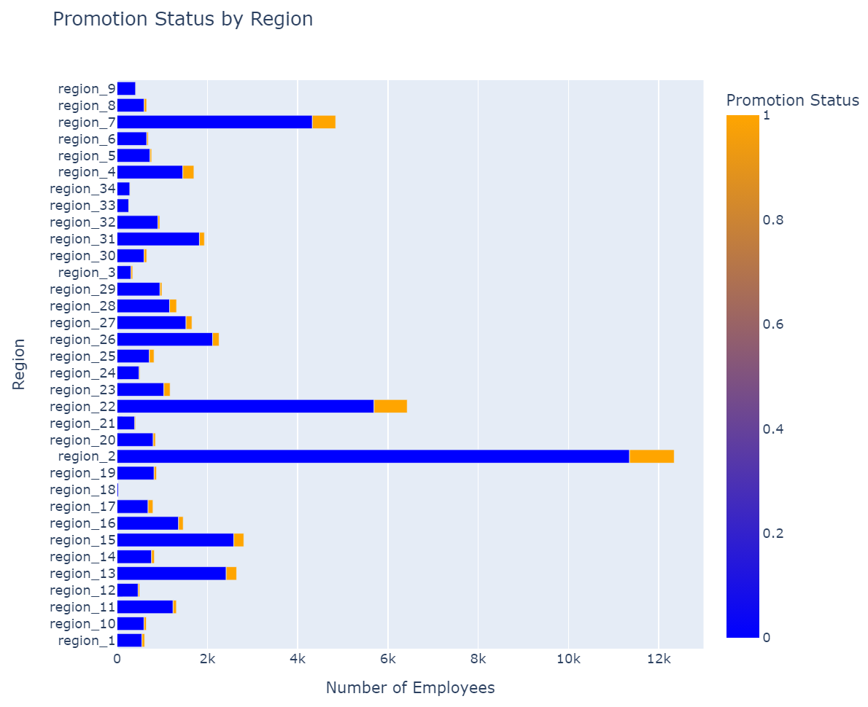

I was expecting no relationship between the region and the number of promotions and the chart above supports my theory as promotions are spread across the regions and geography should not determine if an employee is promoted.

**Education vs is_promoted**

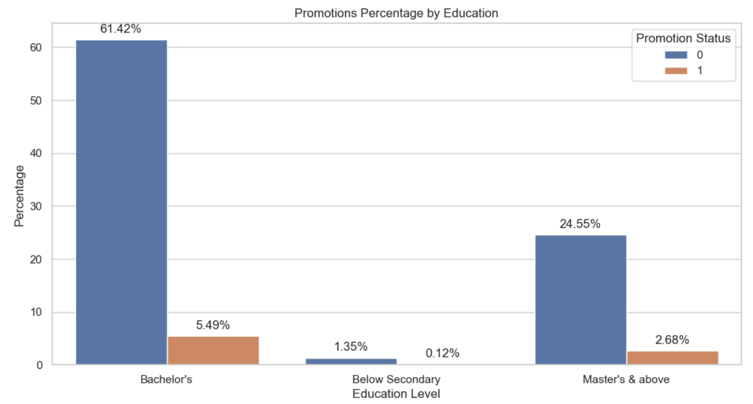

I was expecting higher promotion rates among employees with higher education as it plays a part in the abilities of an employee to perform tasks. The chart supports my theory as only 0.12% of employees, having below secondary education got promoted while more than 8% of employees who had degrees were promoted.

**Gender vs is_promoted**

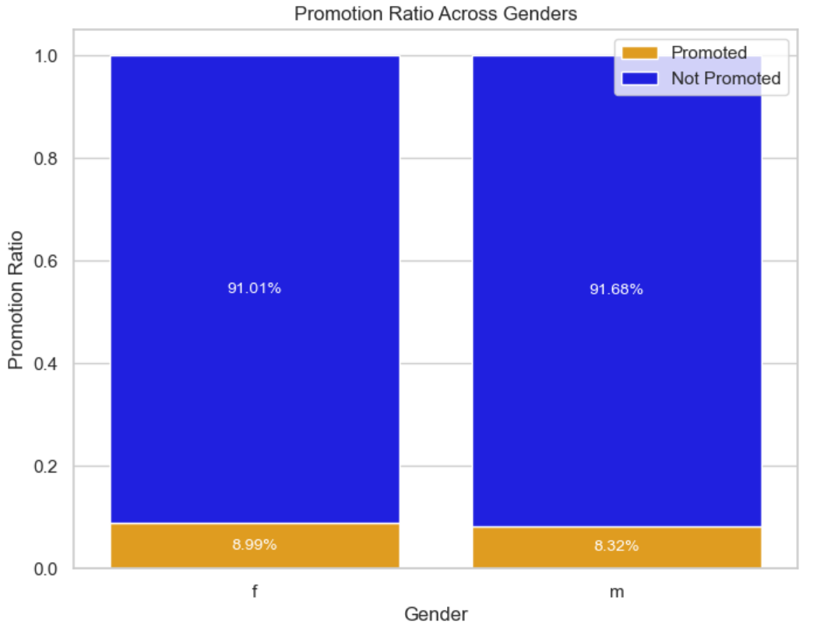

The chart shows no patterns between gender and promotions and promotions are equal among the genders. There is no relationship between gender and promotion status and in the modern world, gender does not affect the chances of promotion.

**Recruitment channel vs is_promoted**

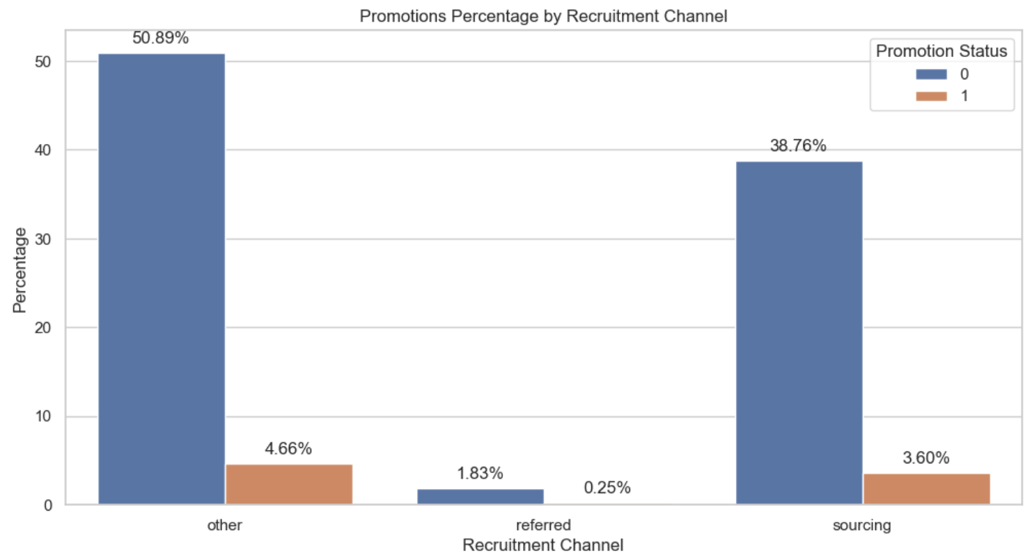

I also expected no patterns between the recruitment channel and promotions as the method through which the employee is hired does not affect promotion.

In summary, I found categorical variables that would be helpful for predictions and identified certain variables which would aid my predictions.

## 2.4.2 Bivariate Analysis of Discrete Numerical Variables with Target

**No_of_trainings vs is_promoted**

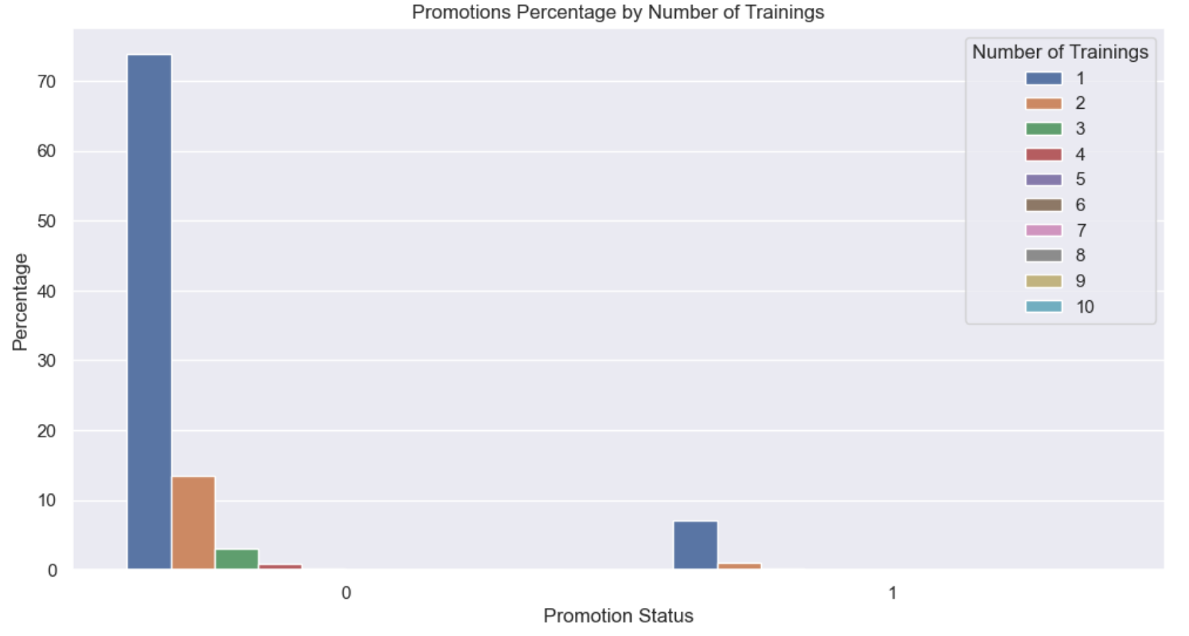

Employees who were promoted only had 1 or 2 trainings and many employees who had more than 2 trainings were not promoted. I was expecting employees who had more trainings to be promoted more as trainings would improve the skills of the employees, increasing promotion chances but this is not true here and this might indicate training programs not being effective.

**Previous_year_rating vs is_promoted**

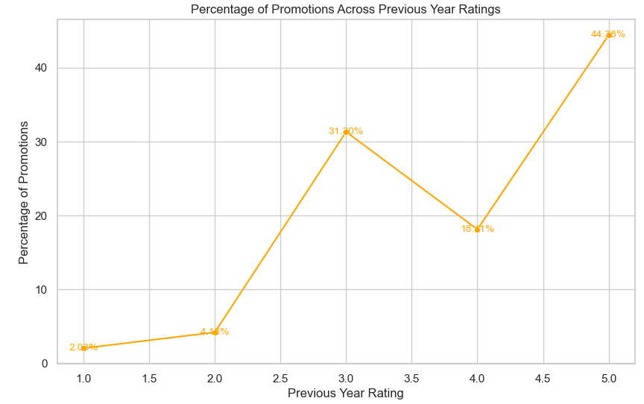

Previous year rating is critical when promoting an employee as employees who had higher ratings had higher promotion rates. The chart on the left shows that promotion rates among 1 rated employees was 2% and it skyrockets to 44% among employees who had 5 rating.

**KPIs_met >80% vs is_promoted**

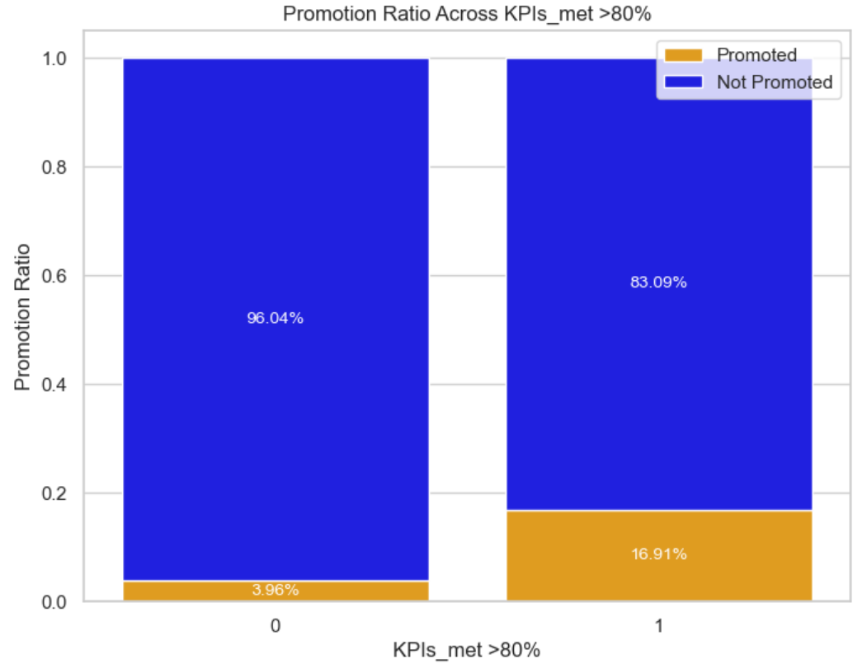

KPI is another direct factor affecting promotions as out of the employees who exceeded 80% of their KPI, almost 17% of them were promoted and this is enormous compared to the 3% of employees who did not exceed 80% of their KPIs.

**Awards_won? vs is_promoted**

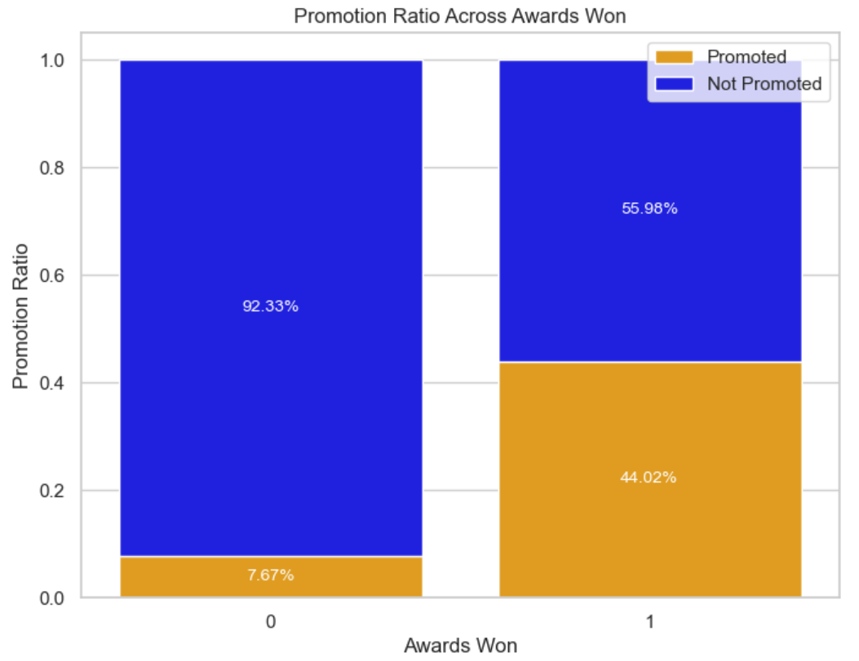

Awards won strongly affect promotion rates as 44% of employees who won awards were promoted while only 7% of employees who did not win any awards were promoted. This is because awards distinguish excellent employees from others.

In summary, I identified more variables with stronger relationships to the target variable.

## 2.4.3 Bivariate Analysis of Continuous Numerical Variables with Target

**Age vs is_promoted**

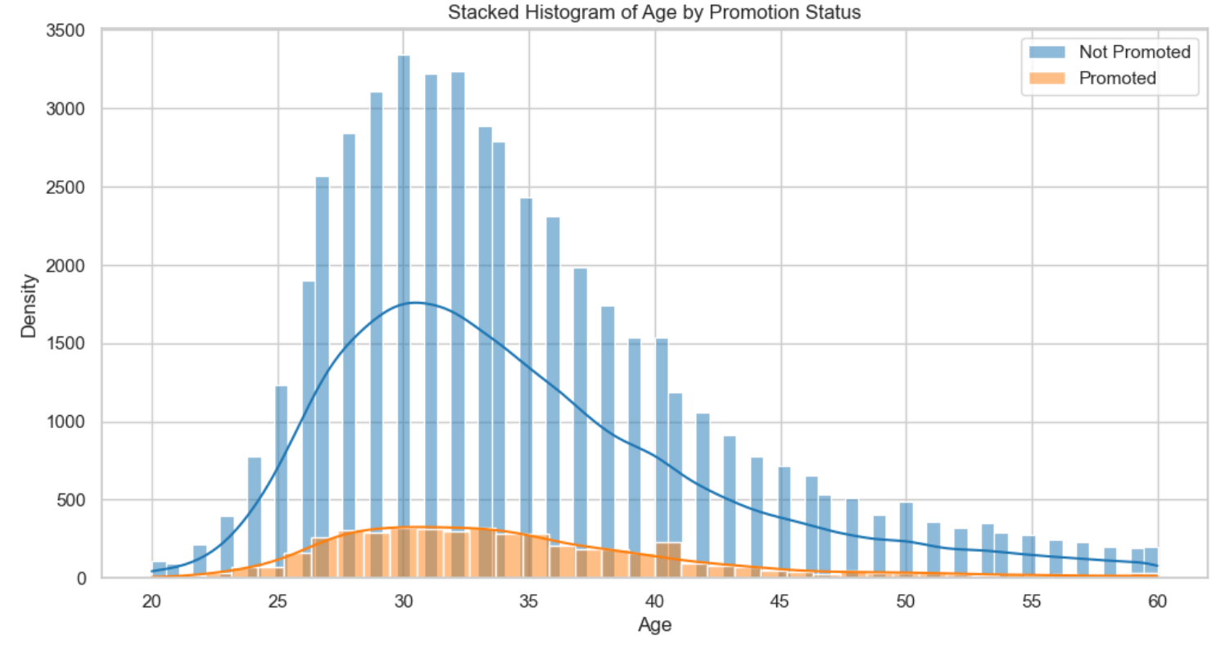

The distribution of age between the promoted and non promoted employees were similar and were right skewed with more employees around the age of 30 promoted. I thought that the distribution of age among promoted employees would be left skewed as I was expecting older employees to be promoted more as they have more experience.

**Length_of_service vs is_promoted**

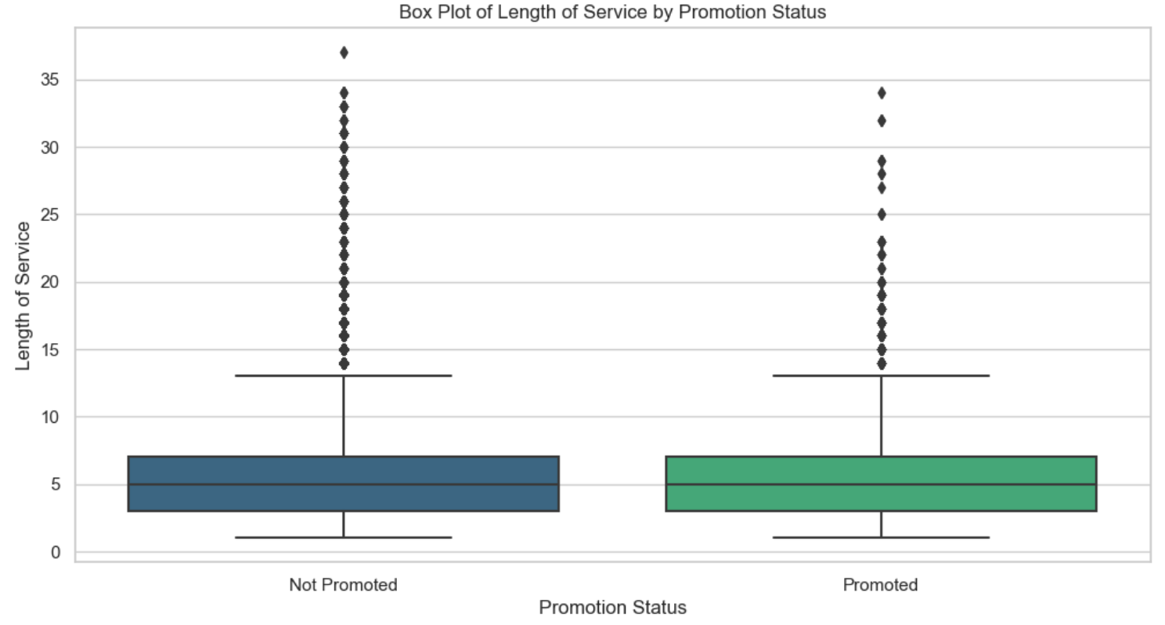

I was expecting employees with a greater length of service to be promoted more often as they have more experience and loyalty towards the company. However, the mean length of service of non-promoted and promoted employees is the same at 5 years.

**Avg_training_scores vs is_promoted**

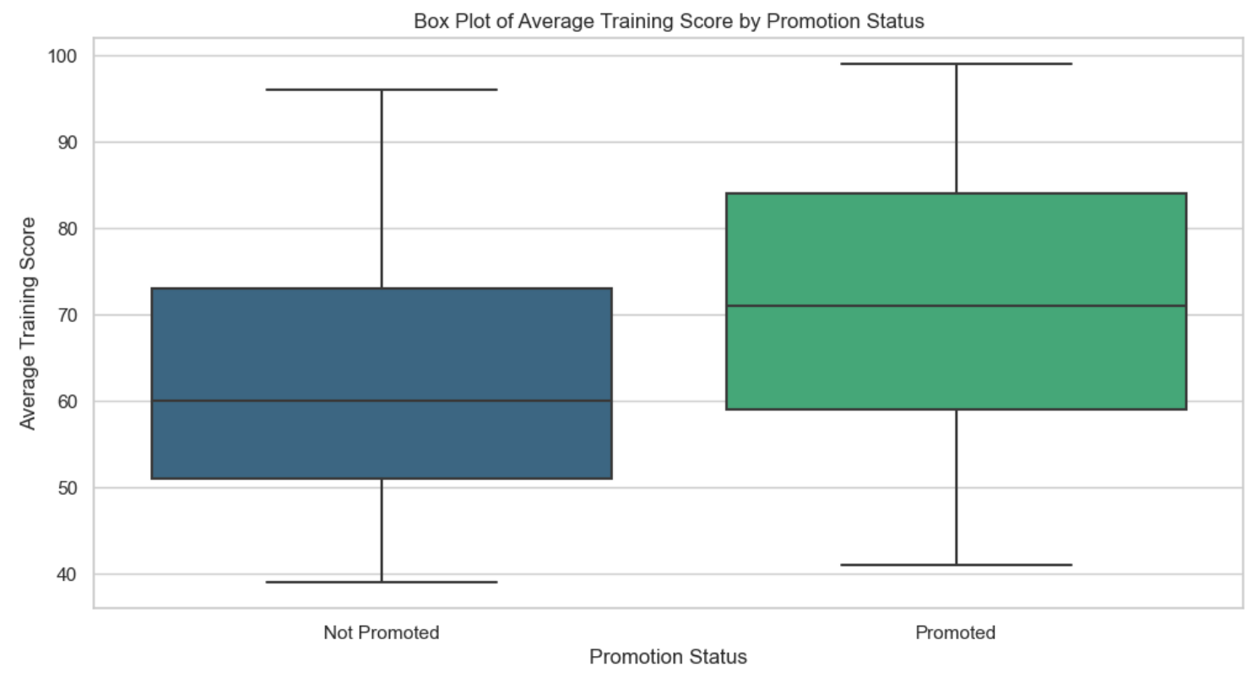

The average training score among promoted employees was higher than the average training score for employees not promoted. The median of the average training score of employees who are not promoted is 60 while that of promoted employees is more than 70.

## Data Cleansing

Data Cleansing has to be done before data transformation as data cleansing removes missing value and changes the data type to make the variables suitable for transformation. Apart from making changes to the data, it also improves the column outside of the data such as the renaming columns.

Current Dataframe:

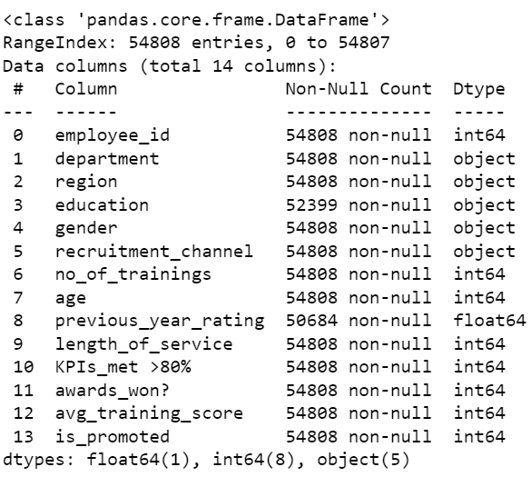

## Renaming Columns

From the above, we can see that ‘KPIs_met >80%’ and ‘awards_won?’ have special characters such as ‘>’, ‘%’, and ‘?’. This is because some machine learning algorithms may interpret these characters as operators, leading to parsing issues.

## Dropping Columns

1. Employee_id

A unique identifier, such as an employee ID, is generally useless for predictions because it lacks predictive power and represents individual instances without inherent patterns. Including it in model training may lead to overfitting, where the model memorizes the identifier rather than learning meaningful relationships in the data, compromising generalization to new instances, due to its high cardinality which might introduce biases.

1. Region

Region has a relatively high cardinality of 34 which is significantly greater than the cardinality of the other categorical variables. It might introduce too many unique values that can affect the ability for meaningful predictions.

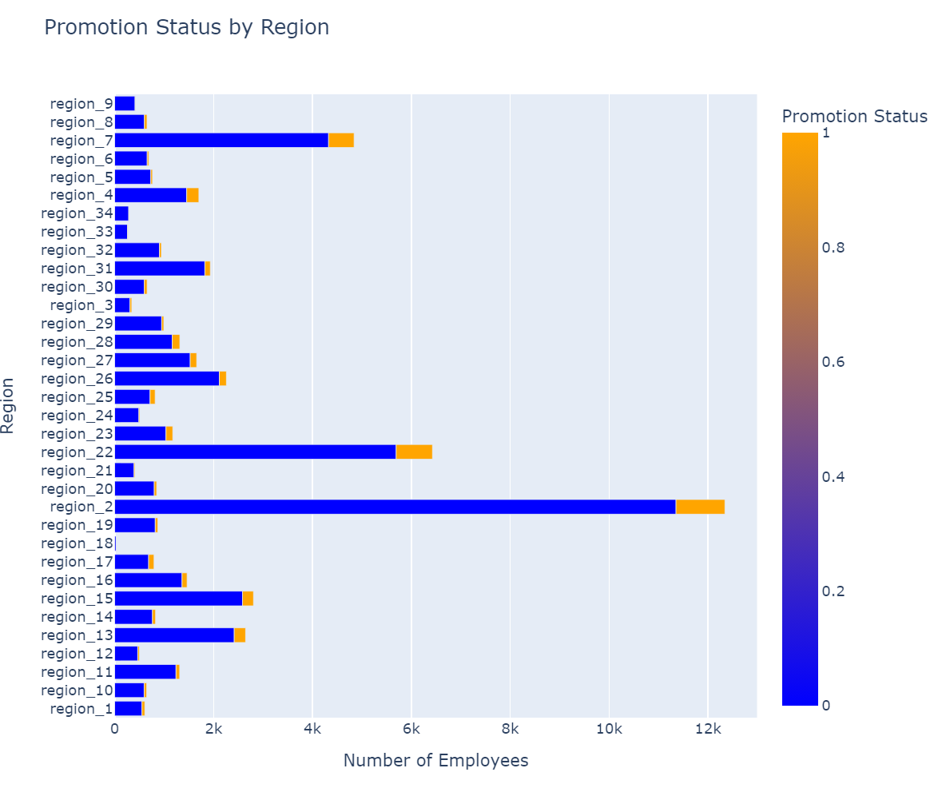

There is also no strong relationship between the region and the target column so it might not contribute meaningfully to the predictions.

1. Gender

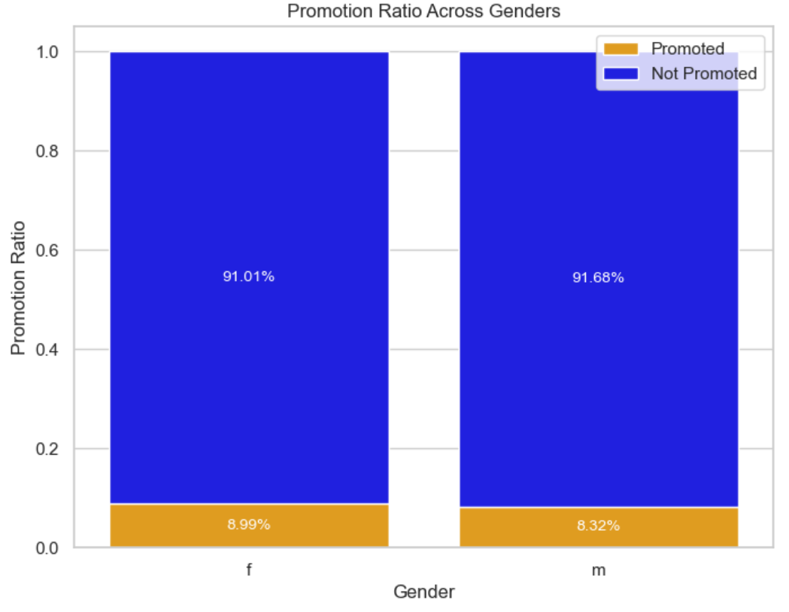

There was no strong relationship between gender and the target variable and in the modern world, since there is greater gender equality, gender does not affect career advancement opportunities anymore. This variable would not aid the model in finding any meaningful patterns for predictions.

1. Recruitment Channel

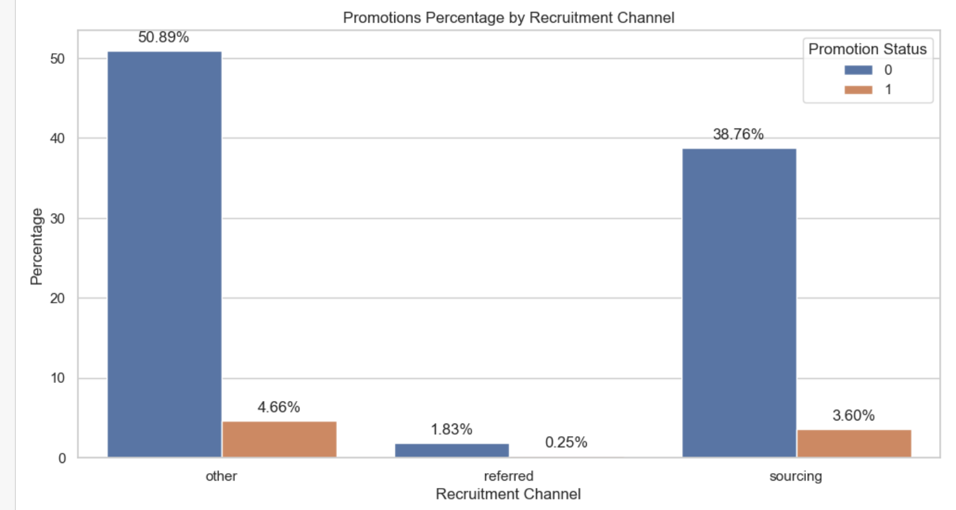

Similar to gender, recruitment channel does not have a meaningful relationship with the target variable and would not be helpful for predictions. The method an employee is hired is not taken into when they are promoted.

## Missing Data Imputation

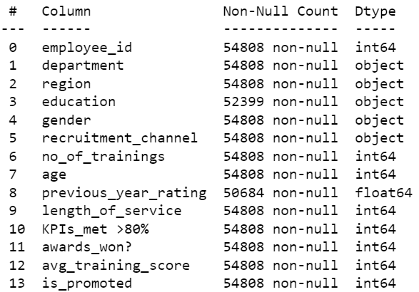

The columns which had null values were ‘previous_year_rating’ and ‘education’. I decided to look for patterns of the missing data of these columns so that I had a better idea of what values to replace the missing values with.

1. previous_year_rating

I started with this column as it had the most missing null values. To find the pattern of missing values, I filtered the data by the null values of previous_year_rating.  
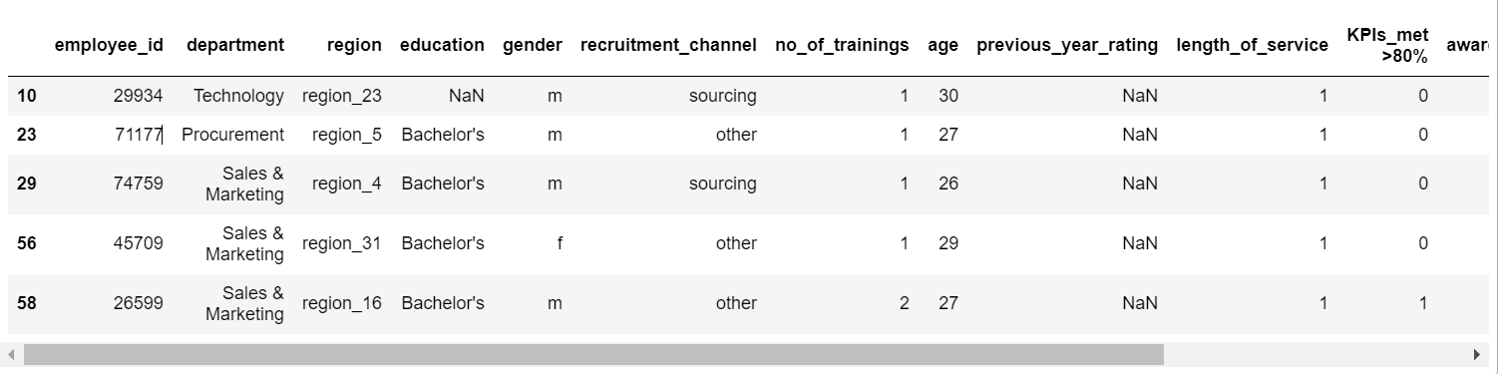

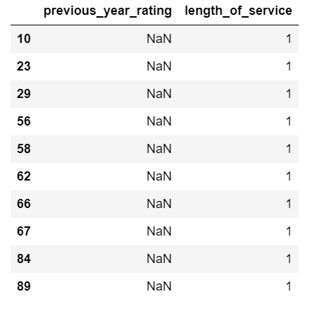

After examining, I found a trend among the missing values of previous_year_rating. The length of service for all employees who did not have a previous_year_rating was 1. This could mean that they are new hires. I decided to impute the missing values of the previous_year_rating of these rows with 0.

1. Education

Next, I filtered the dataset with the missing values of education.

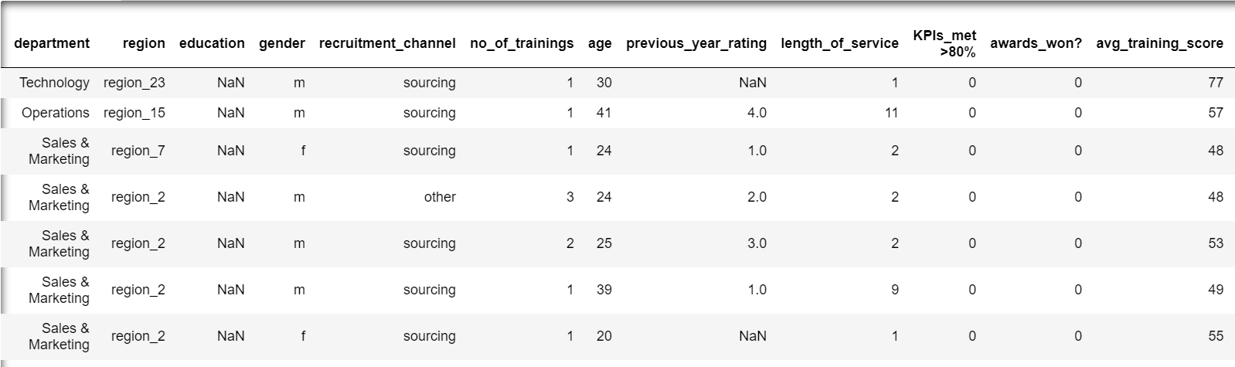

However, unlike previous_year_rating, I could not find any pattern with the other variables. Hence, I decided to explore education further and I thought that no_of_trainings would have the strongest relationship with education. I thought that employees with higher education would not require too much additional training.

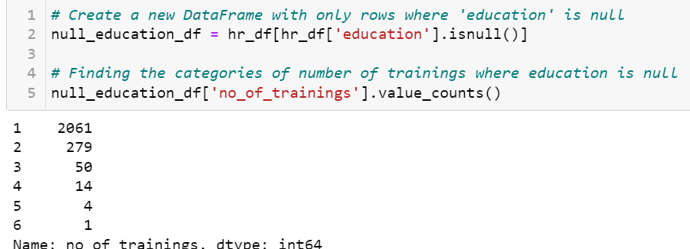

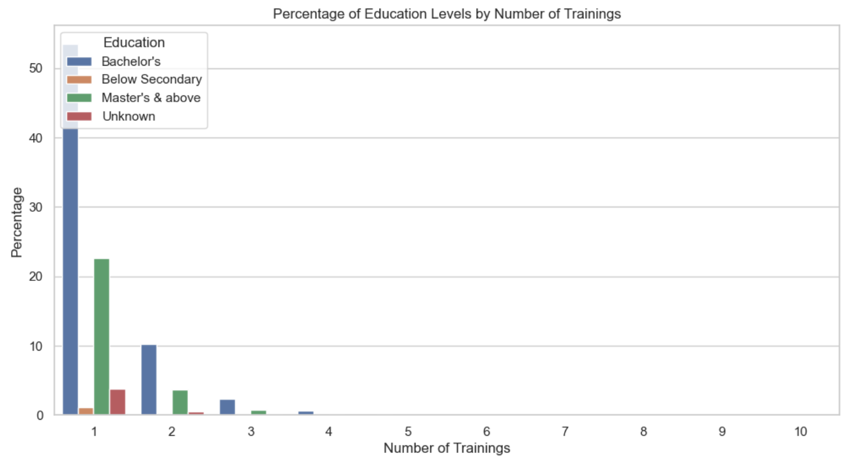

Unfortunately, there was no pattern. However, upon closer inspection of the education categories, I noticed that there was a big jump from ‘Below Secondary’ to ‘Bachelor’s’. However, it is also possible for employees to have achieved diplomas.

Hence, I decided to impute the missing values with ‘Diploma’.

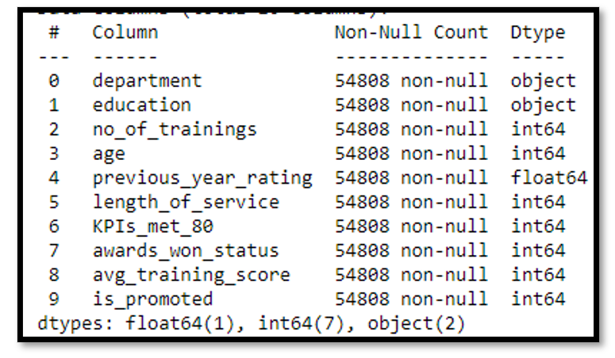

There are no more missing values.

## Data Transformation

## Categorical Encoding

Categorical encoding is crucial for machine learning algorithms because many algorithms require numerical input, and categorical data is typically non-numeric. This allows algorithms to better understand and utilize these features for training models.

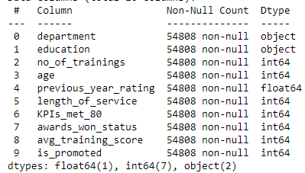

After data cleansing, my dataframe had two categorical variables, department and education. There are many encoding methods available for different use cases.

1. Encoding department

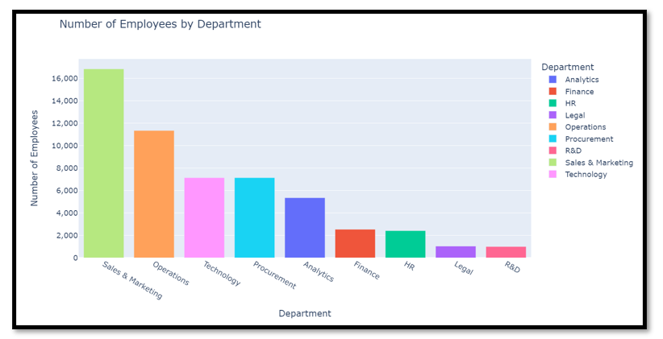

‘department’ is an unordered categorical variable as there is no order across the categories. Hence, one hot encoding is used to represent each category as a binary feature, enabling machine learning models to understand and distinguish between categories without introducing any ordinal relationships that might mislead the algorithm.

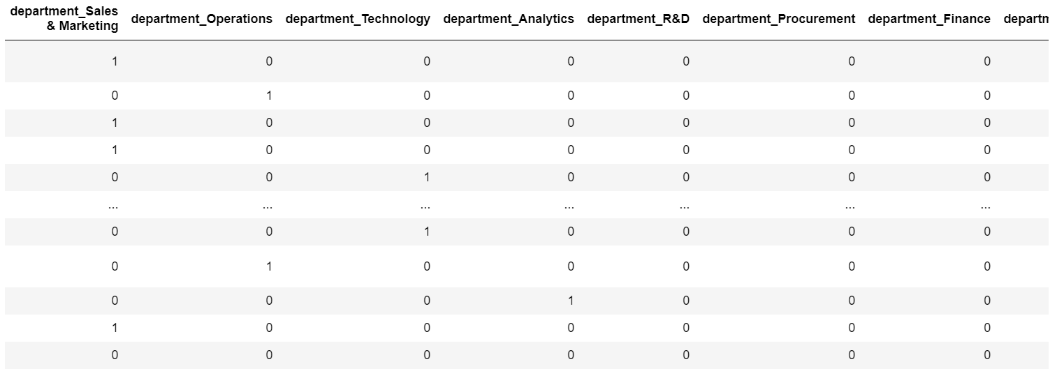

After encoding, a new column is created for each category. 1 indicated presence of that category and 0 indicates absence in that row.

1. Encoding education

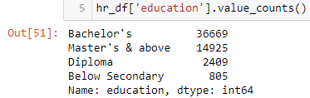

Categories in education follow an order with below secondary, diploma, bachelor’s and lastly Master’s & above. Ordinal encoding is used for ordered categorical variables to represent the inherent order or ranking among categories, providing a numerical representation that preserves the ordinal relationships and allows machine learning models to leverage the structured nature of the data.

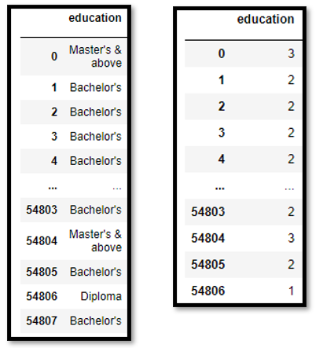

The picture on the left shows the categories before encoding and the picture on the right shows the categories after encoding, the categories are represented by numbers from 0 to 3 in their order i.e. Master’s & Above is assigned 3 as it is the last category.

## Numerical Transformation

Numerical transformation is done on continuous numerical variables and is important to address skewness and outliers which can introduce biasness.

1. Age

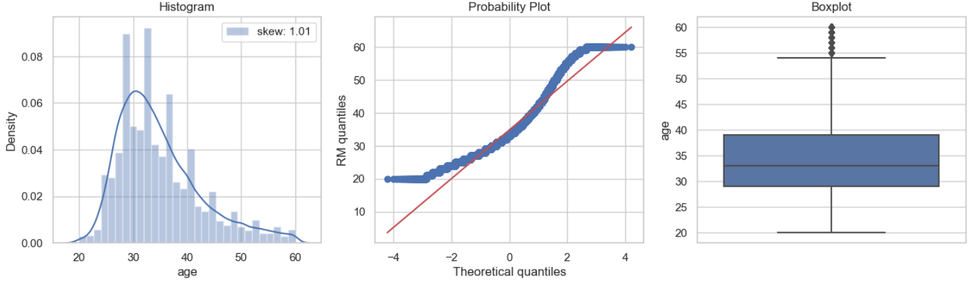

Before Age Transformation

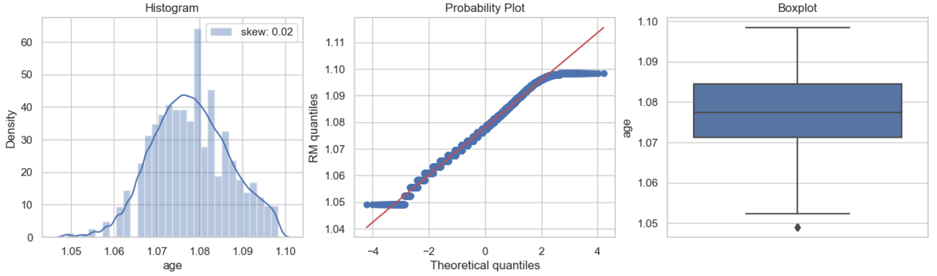

After Age Transformation

Box-Cox transformation was the most effective on the age column and it reduced the skewness from 1.01 to 0.02 so the distribution has become more normal than before. Box-Cox transformation is most suitable for positive data with right skewness. After the transformation, there were less outliers as seen from the box plots.

1. Length_of_service

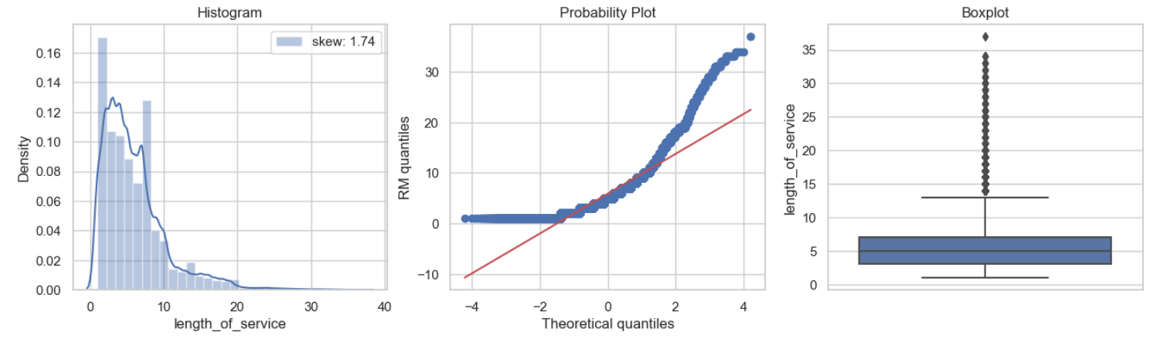

Before length_of_service Transformation

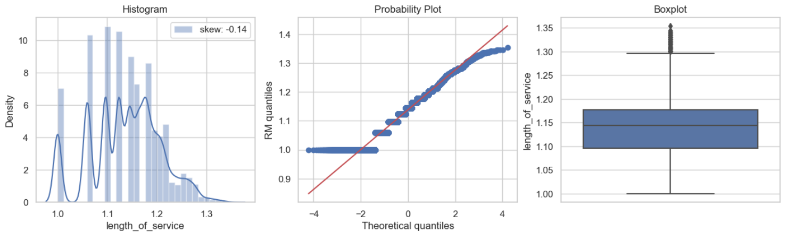

After length_of_service Transformation

Power transformer with a power of 0.084 proved to be the best transformation after heavy testing. It is more normal now as the skewness is closer to 0. The outliers are also less spaced out and closer to the upper boundary of the boxplot.

1. Avg_training_score

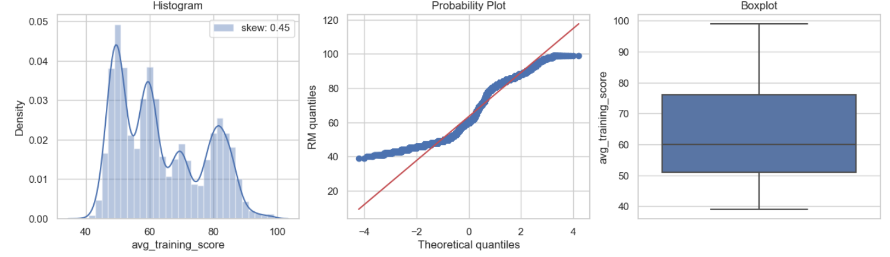

Before avg_training_score Transformation

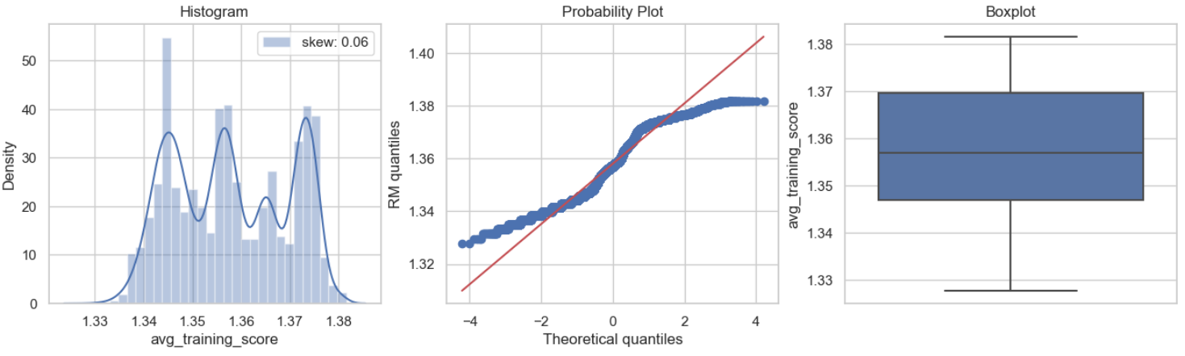

After avg_training_score Transformation

The best transformation was the box-Cox transformation as the variable had varying degrees of skewness as there was a high density of lower scores and higher scores.

## Handling Outliers

Outliers can skew model parameters, impact predictive accuracy, and compromise generalization to new data, leading to biased and unreliable results. After transformation, age and length_of_service variables still had outliers that had to be handled.

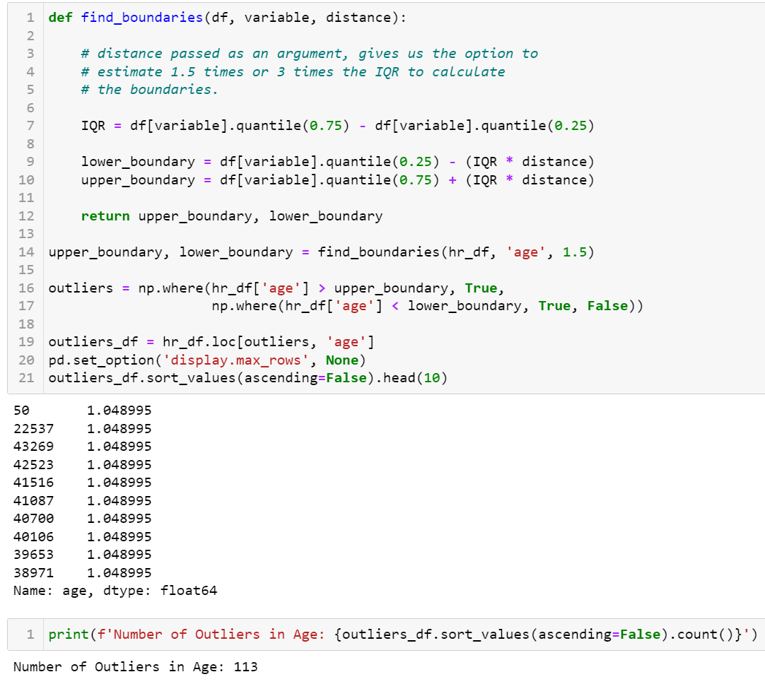

Number of Outliers in age

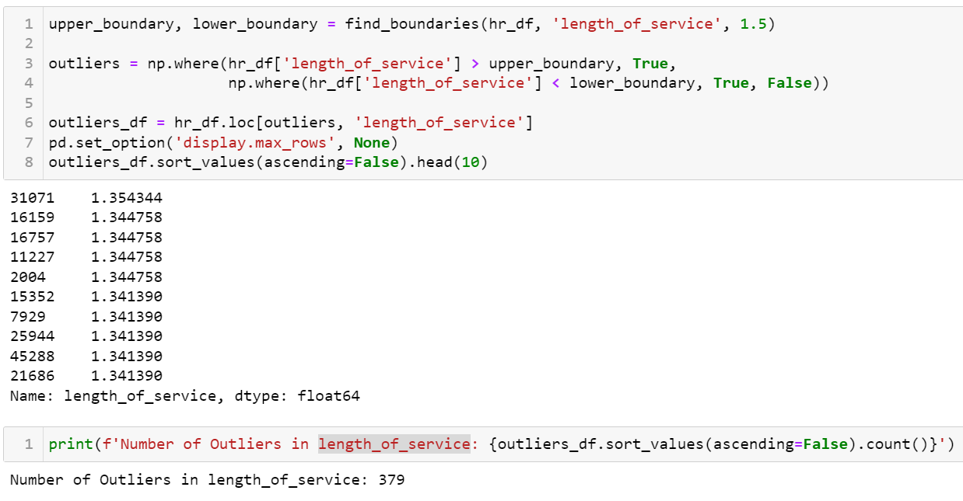

Number of Outliers in length_of_service

There is a significant number of outliers in both the variables so trimming of outliers would result in significant loss of information. The high number of outliers makes winsorization the best option as it preserves the highest amount of information while still reducing the impact of outliers. This is also why winsorization is better than capping.

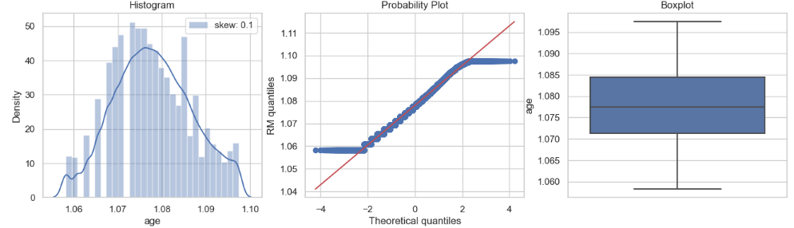

age variable after winsorization

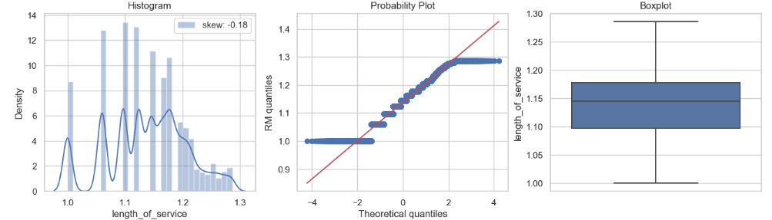

length_of_service after winsorization

Winsorization at the 99th percentile managed to removed all the outliers for both the variables.

## Scaling

Scaling is typically applied to continuous variables because it involves transforming the values of a variable to a standard scale. Continuous variables can have different ranges and units, and scaling helps ensure that all variables contribute equally to the analysis, preventing those with larger scales from dominating the others. Algorithms that are distance-based, such as k-nearest neighbors (KNN) or support vector machines with certain kernels, may benefit from feature scaling.

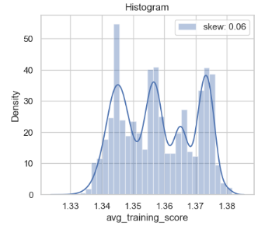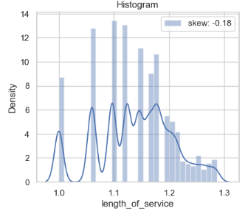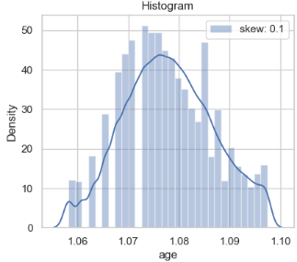

avg_training_score scale

length_of_service scale

age variable scale

From the above histograms, we can see that the continuous variables have varying scales so scaling is required.

1. Mean Normalisation

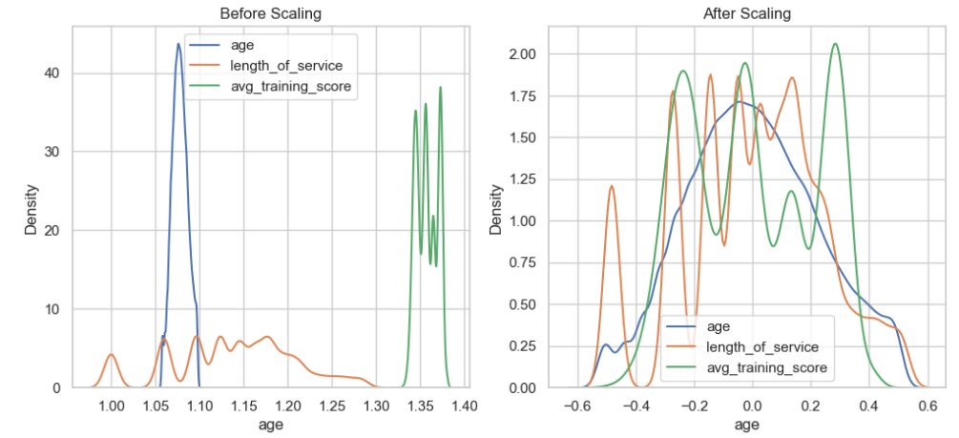

1. Min-Max Scaling

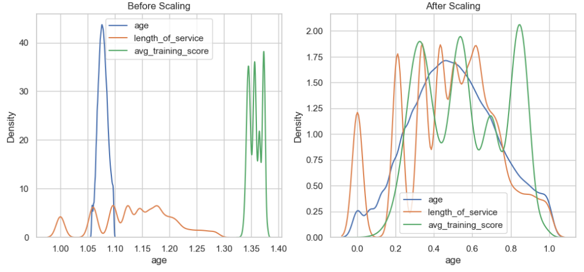

1. Maximum Absolute Scaling

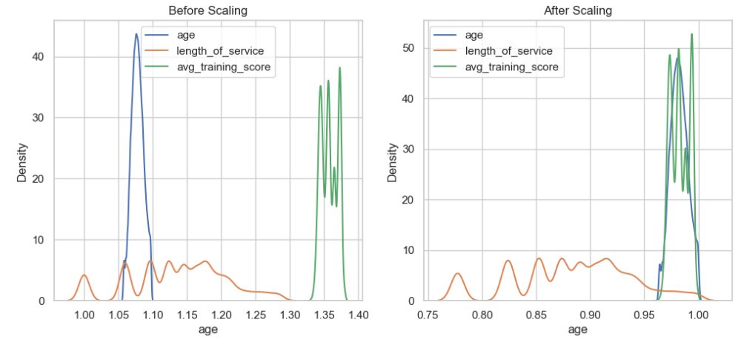

1. Robust Scaling

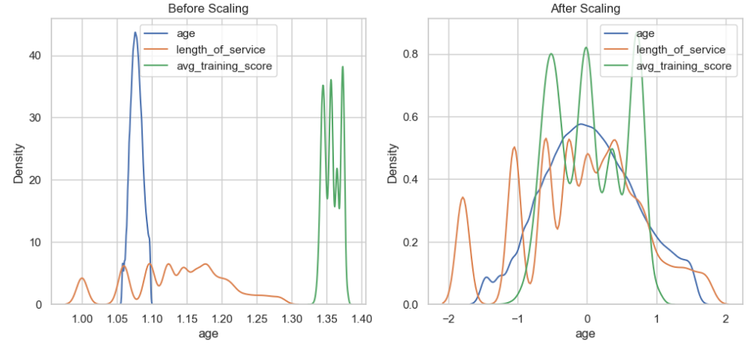

1. Standard Scaling

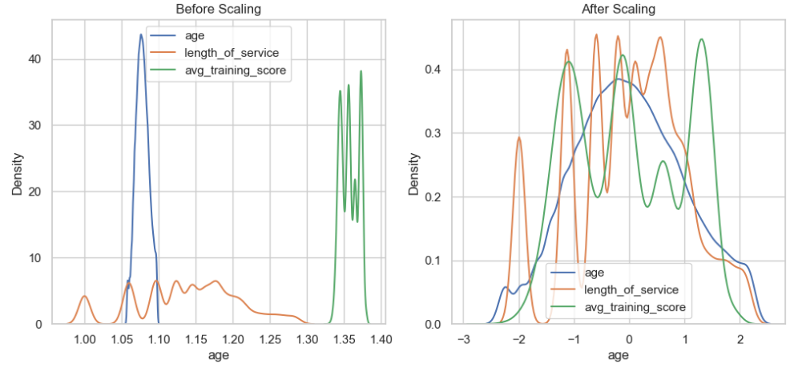

Standard Scaling turned out to be the best scaling method as the scales of the variables are the most similar after standardisation. Standardization is the process of centering the variable at zero and standardizing the variance to 1 and it preserves the original distribution of the data.

## Transformations that were not required

Discretization was not necessary because for binary classification problems because binary classification deals with two discrete classes (positive and negative), and the models used for such problems (e.g., logistic regression, decision trees, support vector machines) are designed to handle binary outcomes naturally.

## Correlation Analysis

For binary classification, correlation analysis is important to identify relationships between independent features and the target variable. It helps uncover which features may have a significant impact on predicting the binary outcome, guiding feature selection and model development. Detecting correlations ensures that relevant information is considered for accurate classification, improving the overall performance of the binary classification model.

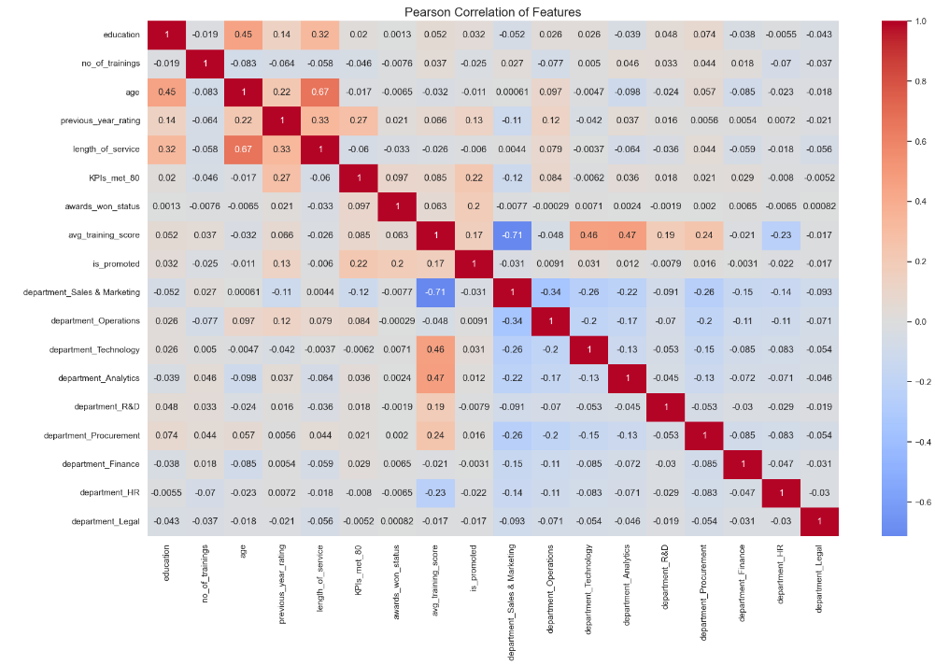

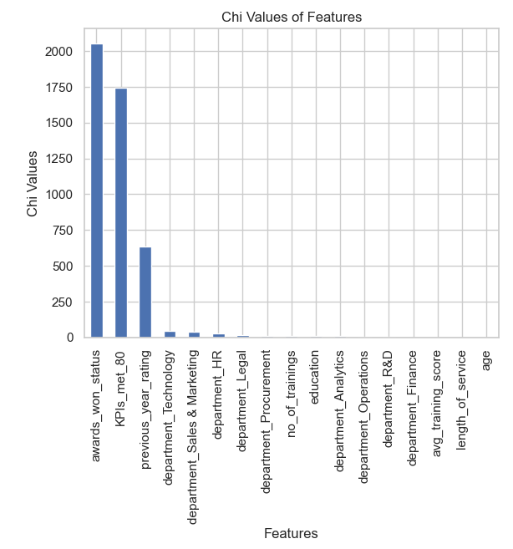

From the pearson correlation and chi square test of our dataframe, we have a better understanding of the relationship between features. Darker red show stronger positive relationships while darker blue show stronger negative relationships. The top 3 features with strongest relationship with the target are awards_won_status, KPIs_met_80 and avg_training_score.

Chi square test determines the feature importance with higher chi values indicating more importance. An employee winning an award is considered most important in this case with a chi value more than 2000.

## Handling Target Variable Class Imbalance

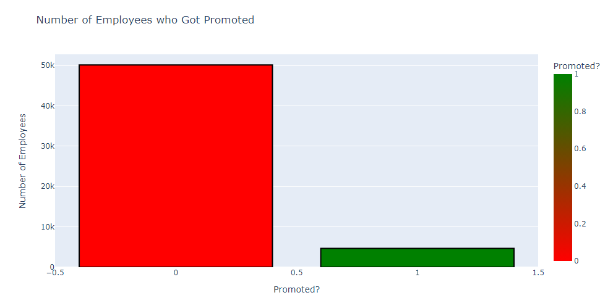

Class Imbalance of Target

From the univariate analysis of the target variable, we can see an obvious class imbalance with majority of samples having `is_promoted = 0`. Class imbalance in the target variable for binary classification is undesirable because it can lead to a biased model that performs poorly on predicting the minority class. The model might become overly influenced by the majority class, leading to low sensitivity (recall) for the minority class, which is of more interest in our case.

Hence, we need to use stratified sampling to sample the equal sized samples of `is_promoted = 0` and `is_promoted = 1`.

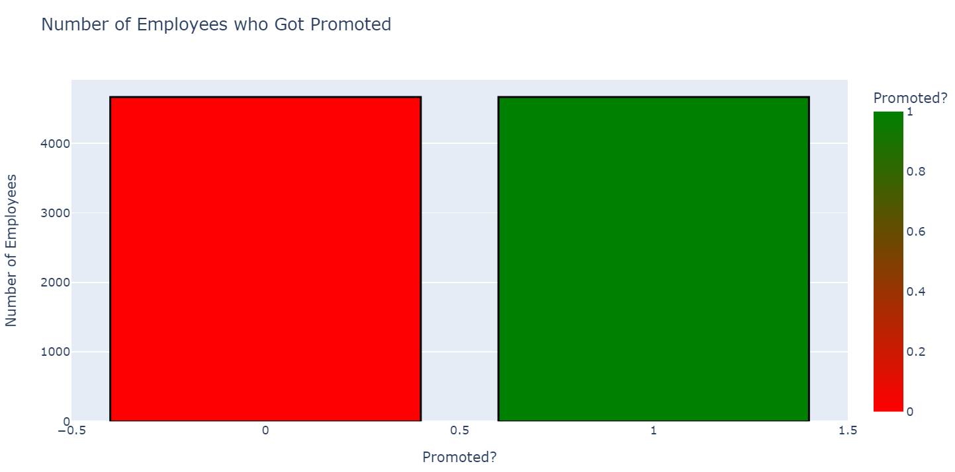

After stratified sampling

Stratified sampling made the class distribution equal and now there will be no biasness for the prediction model.

# AIRBNB (Regression Problem)

In this section of the report, I will be sharing more about the insights I have drawn from the data exploration of the airbnb dataset and the preparation of data the linear regression problem.

## Problem Understanding

The linear regression problem involves predicting the rental price of the listed properties. This will be beneficial for a variety of the stakeholders including hosts and clients and presents them with different benefits. For hosts, they can find out the best prices to set for their listings to remain competitive and for customers, they will be able to find the best Airbnb deals ahead of time. Key features influencing promotions will be identified, aiding in HR decision-making for talent management and organizational growth.

## Data Understanding

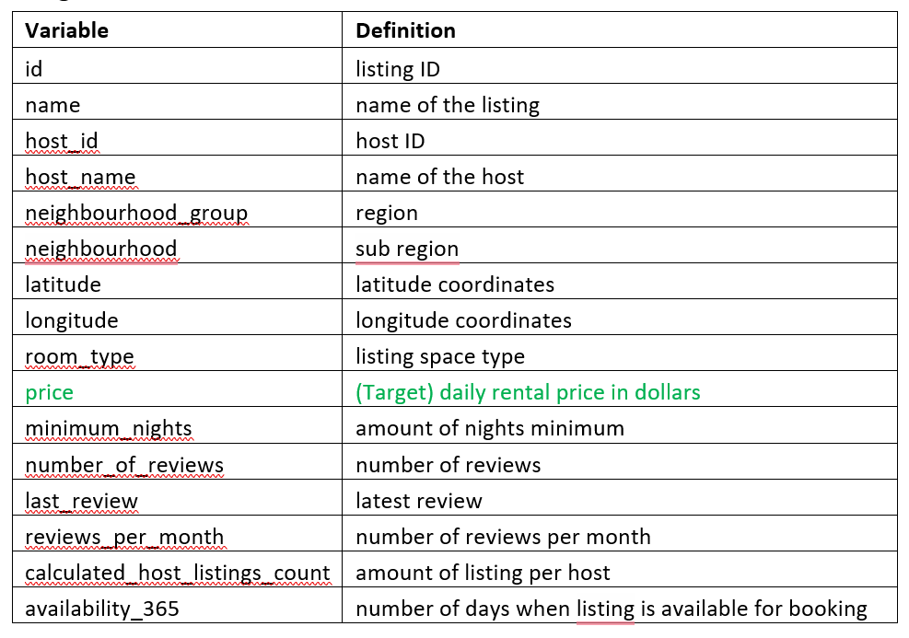

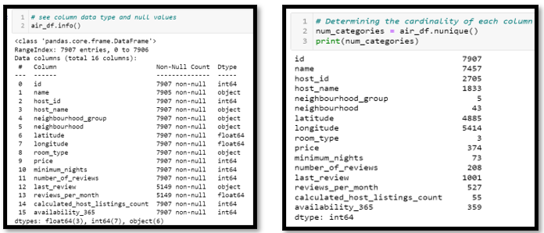

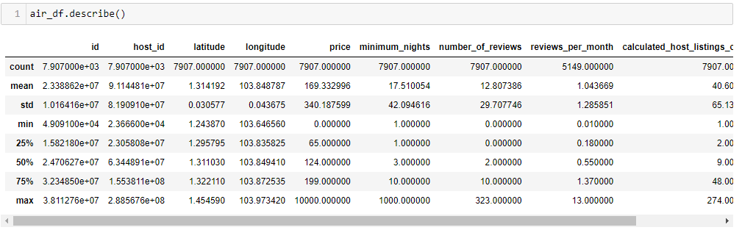

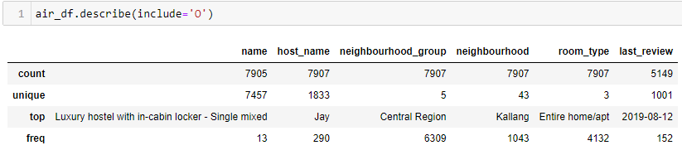

From this, I had a better understanding of the data values, data types of the variables, number of null values and the cardinality of the variables. Now that I knew which columns had null values, I could focus on these columns later to try to find patterns to fill these null values. After knowing the data type and cardinality of the numerical features, I have a better idea of the variables to treat as categorical and which numerical variables to treat as discrete or continuous. From this, I found there were no discrete numerical variables apart from the listing and host unique identifiers and the rest of the numerical variables were of continuous nature.

## 3.3 Univariate Analysis (Data Exploration)

Next, I moved on to understand each of the variables from an individual standpoint. There is a narrower focus on each variable, aiding in understanding the distributions and patterns within the variable. In the context of this airbnb dataset, I will be finding more information of the patterns of the individual elements of the listings.

## 3.3.1 Univariate Analysis of Categorical Variables

**Host_id**

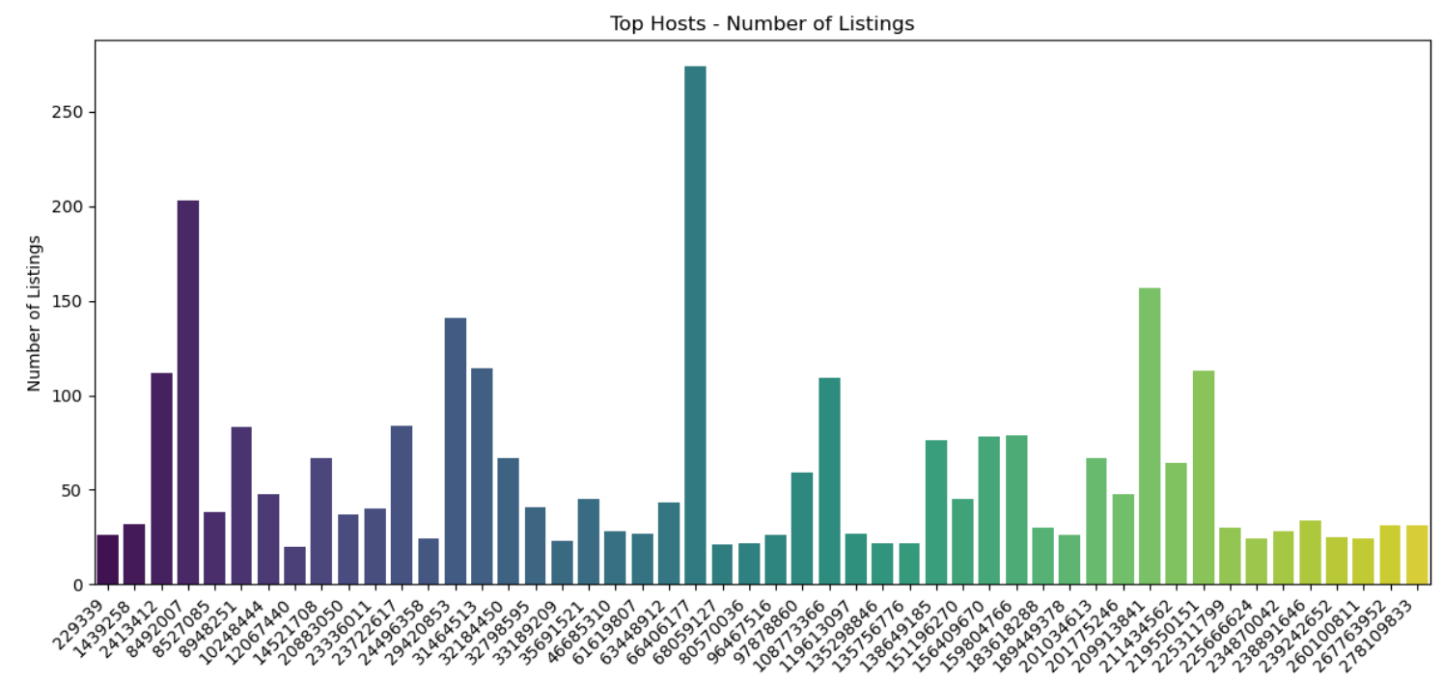

Due to the high cardinality of host_id of 2705, I decided to only visualize the top hosts with the highest number of listings. Most of the top hosts have made about 50 unique listings with one host making a significantly higher number of listings of more than 50 unique listings. Univariate analysis on host_id helps understand host distribution, identify influential hosts, and assess their impact on the dataset.

**Host_name**

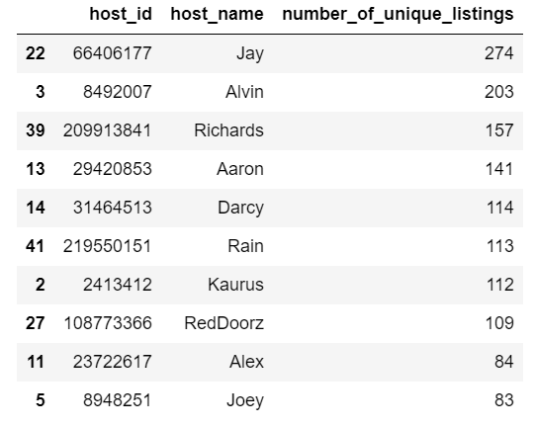

After finding the top host_ids with the highest number of unique listings, I further explored the host data by finding out the names of these hosts as this would help me better identify these hosts. After creating the table visual, we have a clearer understanding of the hosts with the highest number of listings and have identified Jay as the host with significantly higher listings than others.

**Neighbourhood_group**

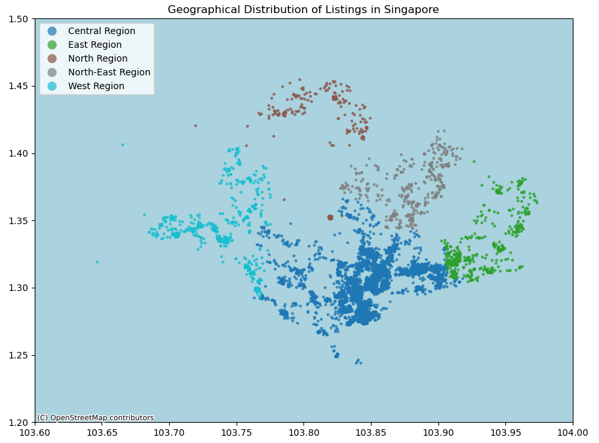

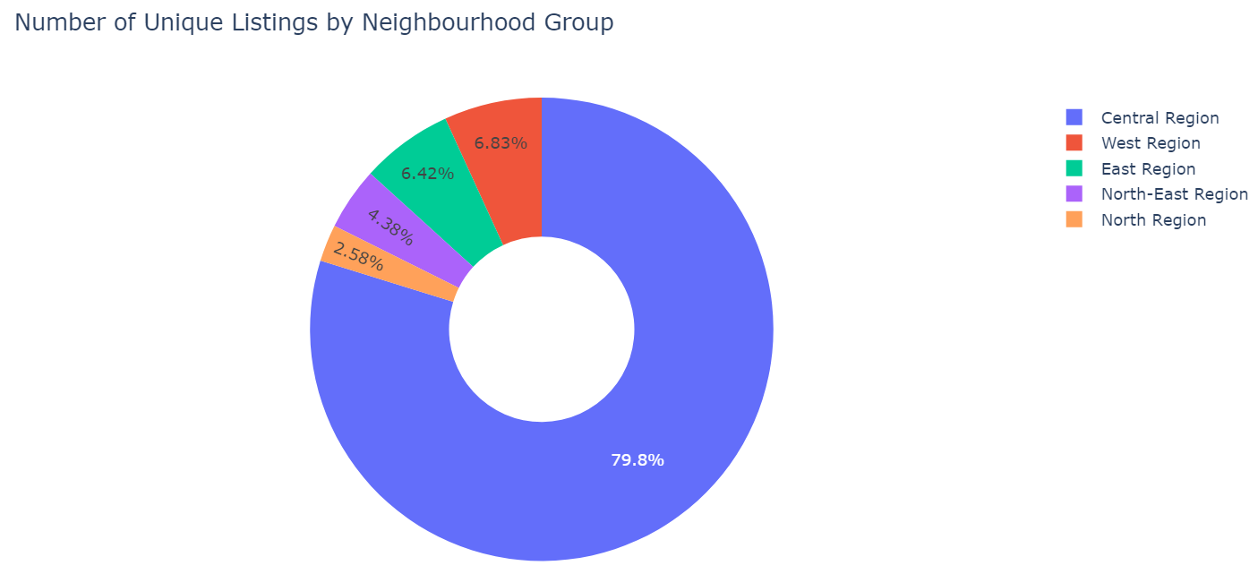

The composition of the number of listings in the different parts of show that the central region has the highest concentration of airbnbs with 79.8% while the north region had the lowest listings with 2.58%. The map visual also shows a large concentration of markers at the central region. Univariate analysis on neighbourhood_group reveals regional distribution, guides targeted analysis, and informs location-specific insights for pricing and occupancy trends.

**Neighbourhood**

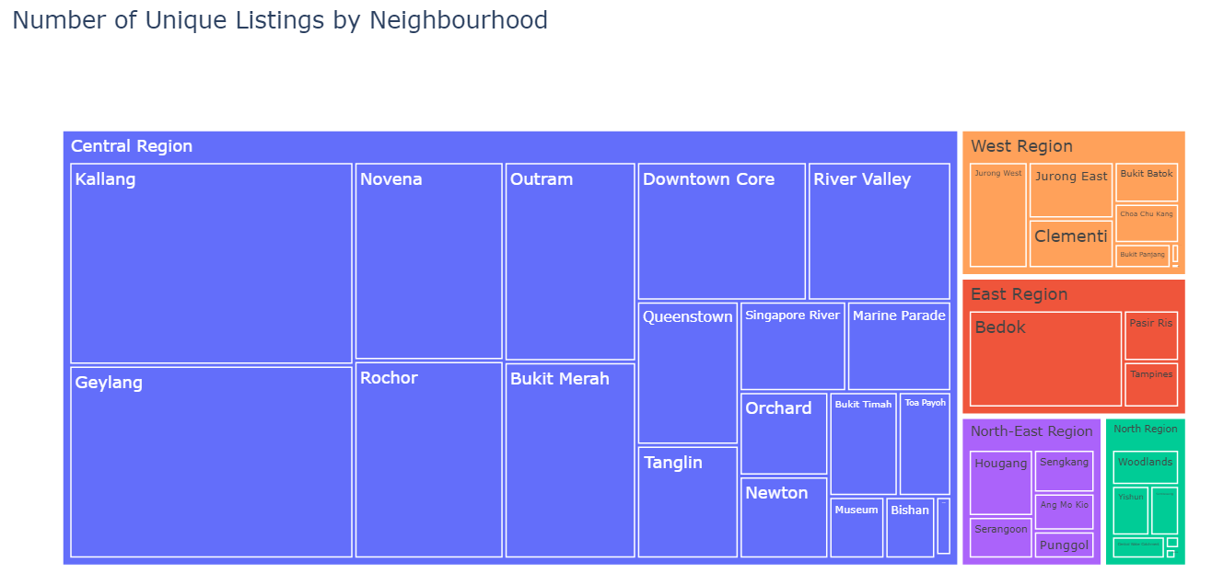

We dive deeper into region data by taking a closer look at the number of listings made in each neighbourhood of each of the neighbourhood groups to better understand the specific neighbourhood groups better. We can have a clearer understanding of the concentration of the airbnbs on a more specific scale.

**Room type**

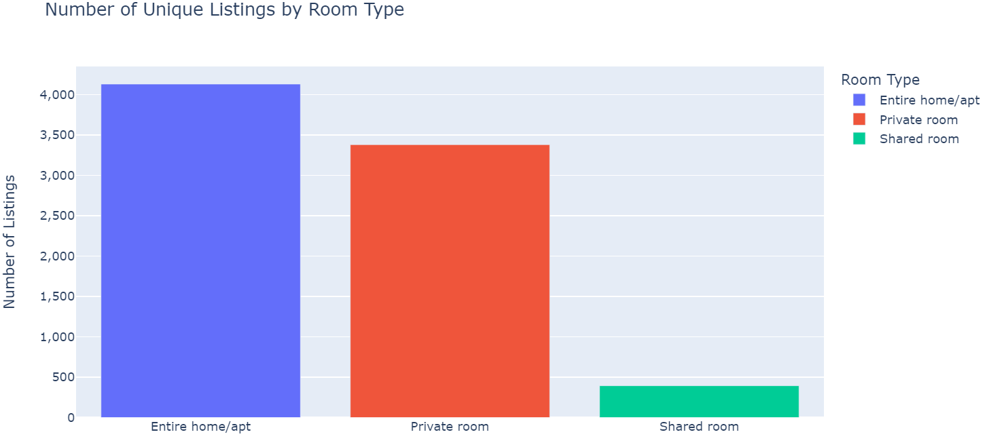

Most of the listings made by hosts are for entire homes with more than 4000 unique listsings for entire homes, followed by private rooms and shared room, which is significantly lower than the other room types with less than 500 unique listings. Univariate analysis on room_type assesses distribution, highlights prevalent listing types, and guides strategic decisions for market positioning and pricing.

**Last_review**

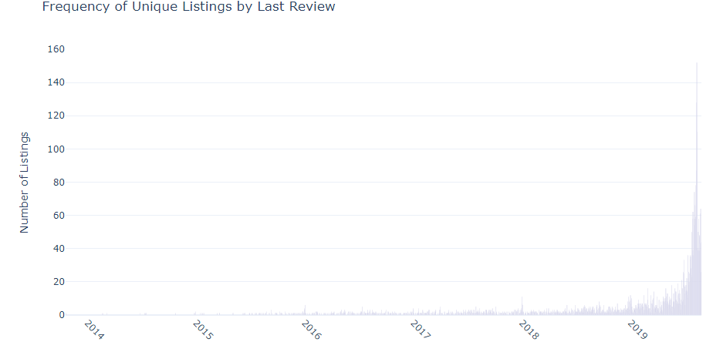

Analysis of the last_review column allows us to have a better understanding of the number of unique listings made across time and we can see that there are significantly greater number of listings during the year of 2019. Univariate analysis on last_review assesses temporal patterns, identifies trends, and informs decision-making, crucial for understanding data dynamics over time.

## 3.3.2 Univariate Analysis of Numerical Variables

Next, I performed univariate analysis on the numerical variables which were all continuous nature and the only discrete variables were the unique identifiers such as listing_id and host_id. For this, I used histograms, probability plots and boxplots to visualize the distributions and identify outliers.

**Minimum_nights**

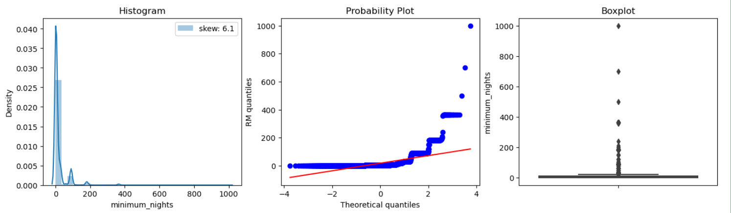

The distribution of minimum_nights is right skewed, indicating that the time requirements for most of the airbnbs are low. This is also seen from the boxplot which shows a low mean. However, the boxplot shows the variable is largely distributed as there is an outlier of 1000 and the outliers are spaced far apart.

**Number_of_reviews**

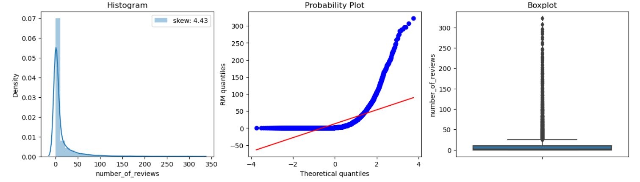

Univariate analysis of the number_of_reviews column allows for better understanding of the distribution of the number of customers who stayed at the Airbnb previously as reviews are made by past customers. The distribution is right skewed which indicates that most listings had fewer customers and the boxplot shows a high number of outliers which means that the difference in the number of customers between the airbnbs is high.

**Reviews_per_month**

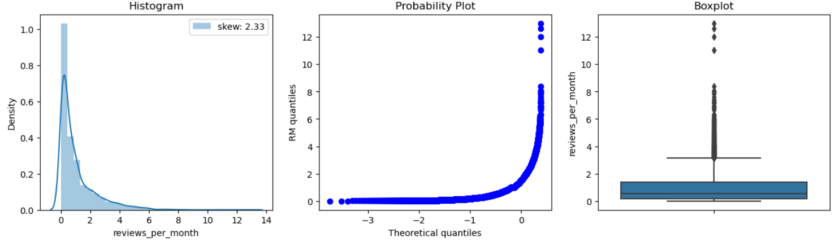

Number_of_reviews and reviews_per_month are similar as the aid better understanding of the distribution of the number of customers of the airbnbs. However, reviews_per_month is distributed on a smaller scale as it shows the information according to the month. The distribution of reviews_per_month is similar to that of number_of_reviews as it is right skewed, but it is less skewed than number_of_reviews.

**Calculated_host_listings_count**

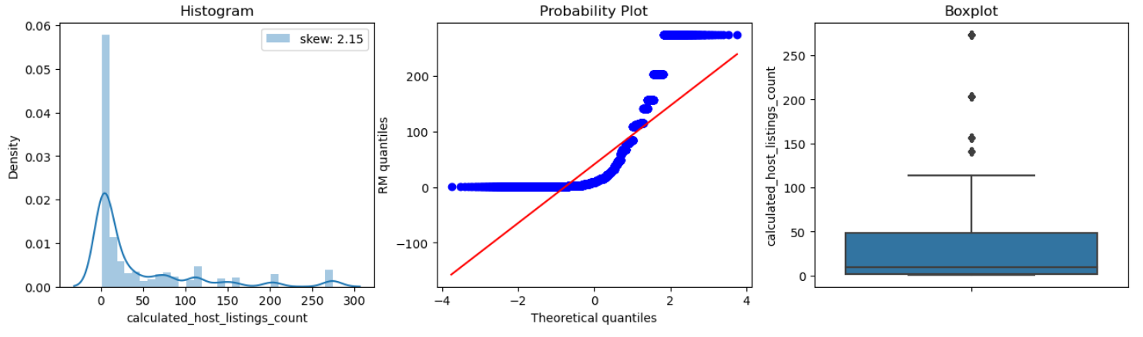

Univariate analysis of the Calculated_host_listings_count allows for better understanding of the distribution of the number of Airbnb properties. The distribution is right skewed which indicates that most listings had fewer properties and there are fewer outliers, meaning that most listings had similar number of properties.

**Availability_365**

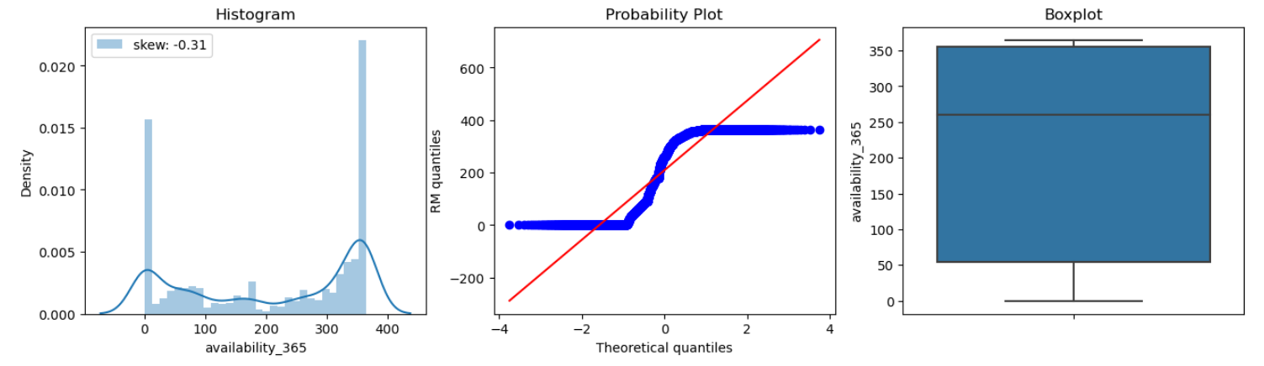

The distribution of availability_365 is left skewed, meaning that more listings were available for a greater number of days. However, there are also a high number of listings which are available for a few days. The box plot also shows that the median number of days airbnbs are available around 250, which is on the higher part of the scale.

**price**

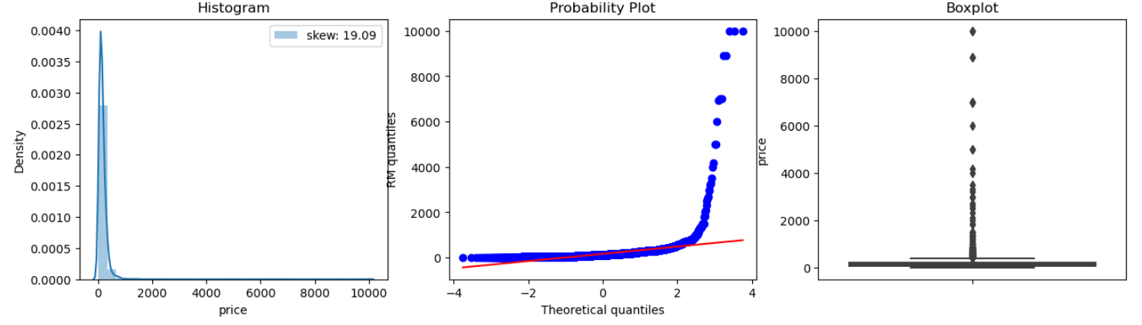

Univariate analysis on price unveils pricing distribution, identifies outliers, and guides strategies for market positioning and revenue optimization. Price is right skewed, indicating that most listings are cheap. However, there are also outliers above the upper boundary which mark listings that are priced way higher than others.

## 3.4 Bivariate Analysis (Data Exploration)

From the univariate analysis, we found that there are many samples and this can be problematic as it can reduce the efficacy and accuracy of the model. Hence, I decided to focus on a subset of the data to build a more specialised model which will be more effective. To decide on the subset of the data I wanted to use, I decided to perform bivariate analysis.

## Number of Customers vs Price

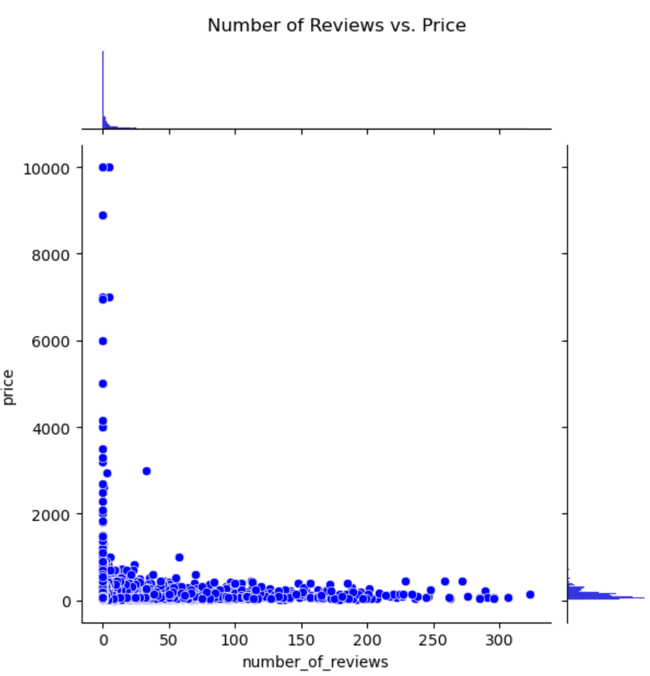

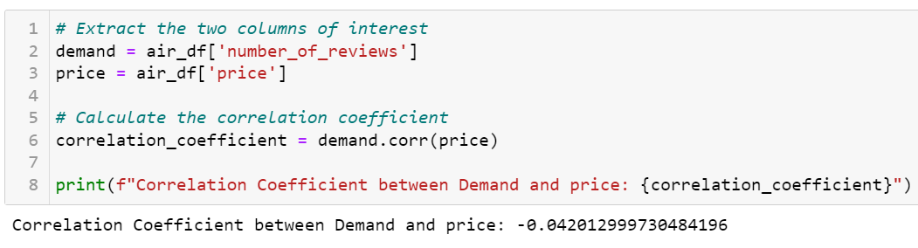

Firstly, I decided to find out the relationship between the number of customers and price. This insight enhances revenue optimization and contributes to more accurate predictions.I used the number of reviews column for this as this column is representative of the number of past customers of that listing. The jointplot shows that there is no linear relationship between number of reviews (number of past customers) and price as the price does not increase with number of reviews. The correlation coeeficient of -0.04 shows a negative relationship in general.

## Room Type vs Price

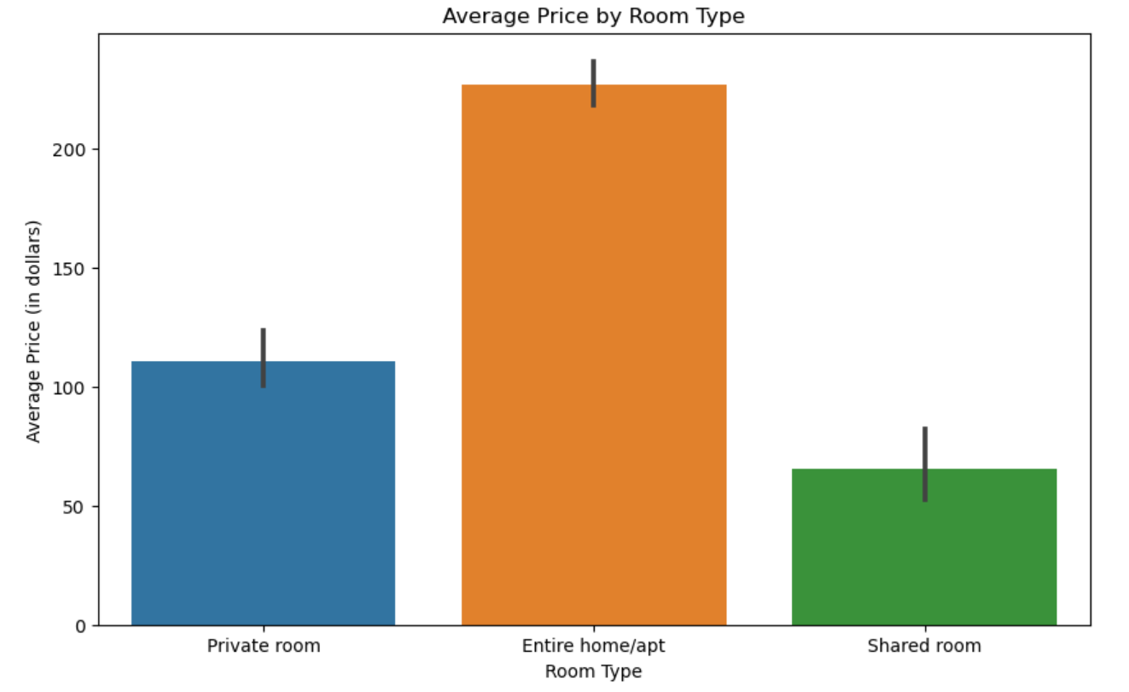

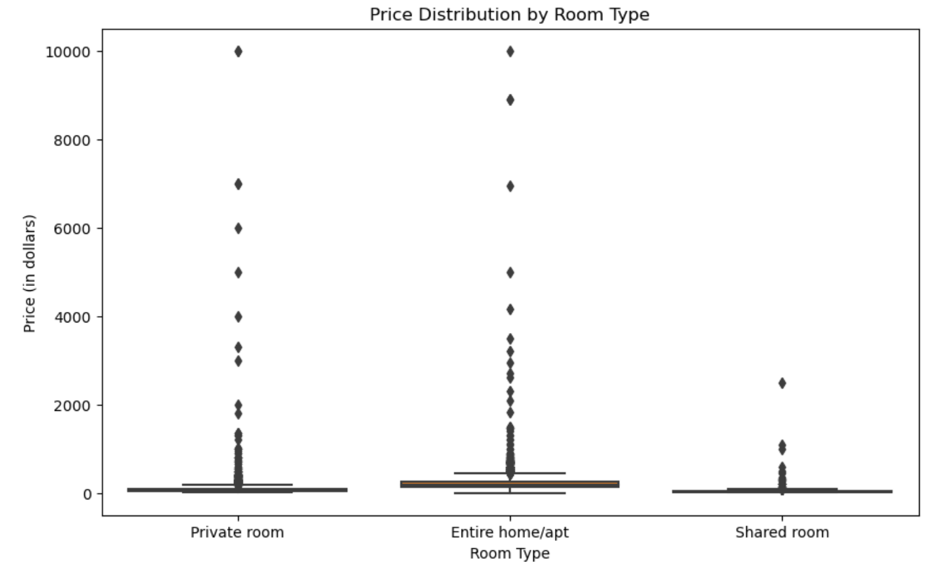

Next, I investigated the relationship between the room type and price because understanding price variations by room type informs optimal pricing strategy, enhancing revenue and customer appeal. I wanted to find out:

1. How does average price vary across the different rooms?
2. Are certain rooms generally more expensive than others?

I found that the most expensive room type with an average price of around $200 is an entire home, followed by private room around $100 and lastly shared room of around $75. From this relationship, I also understood that bigger rooms are generally more expensive. Also, the price for the bigger listings had a greater variety as seen from the more spaced out distributions.

## Room Type vs Availability

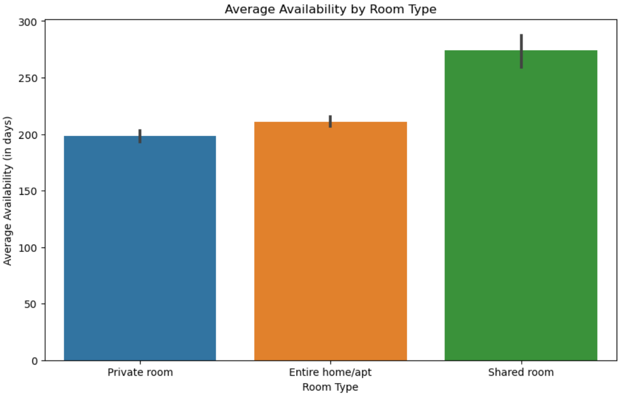

Analyzing room type versus availability helps understand the demand of the different room types and optimize inventory management by identifying popular and readily available room types. This aids in meeting customer preferences, maximizing bookings, and ensuring efficient resource allocation. Shared rooms usually had more availability on average of around 250 days. Entire homes and private rooms had similar availability of around 200 days, with private rooms having a little less below 200 days.

## Geographical analysis of Customers

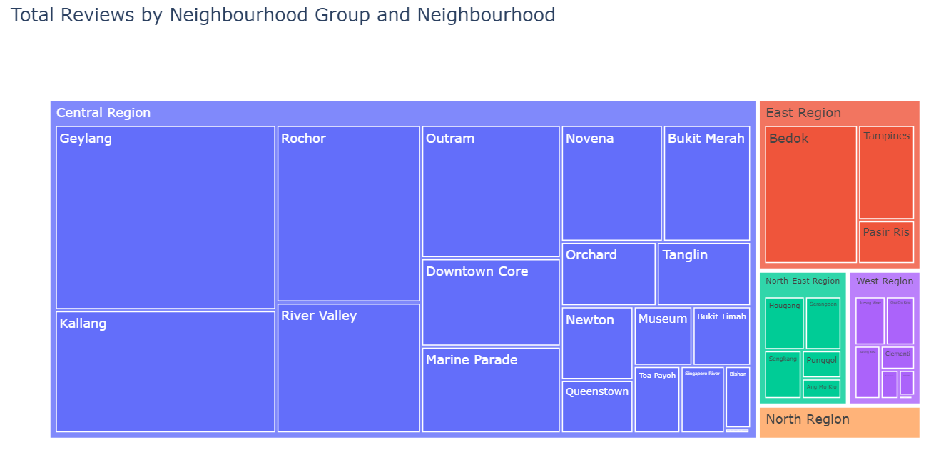

I found the relationship between the geography and customers as this shows the demand of the Airbnb between different parts of the country. Geographical analysis identifies customer locations, optimizing targeted marketing and tailoring services to specific regions for enhanced business strategy as it shows the popular locations of customers and this can help hosts decide on the location of their listing. From the treemap, we see the central region tends to be the most popular among customers and north region being the last.

## Geographical analysis of Price

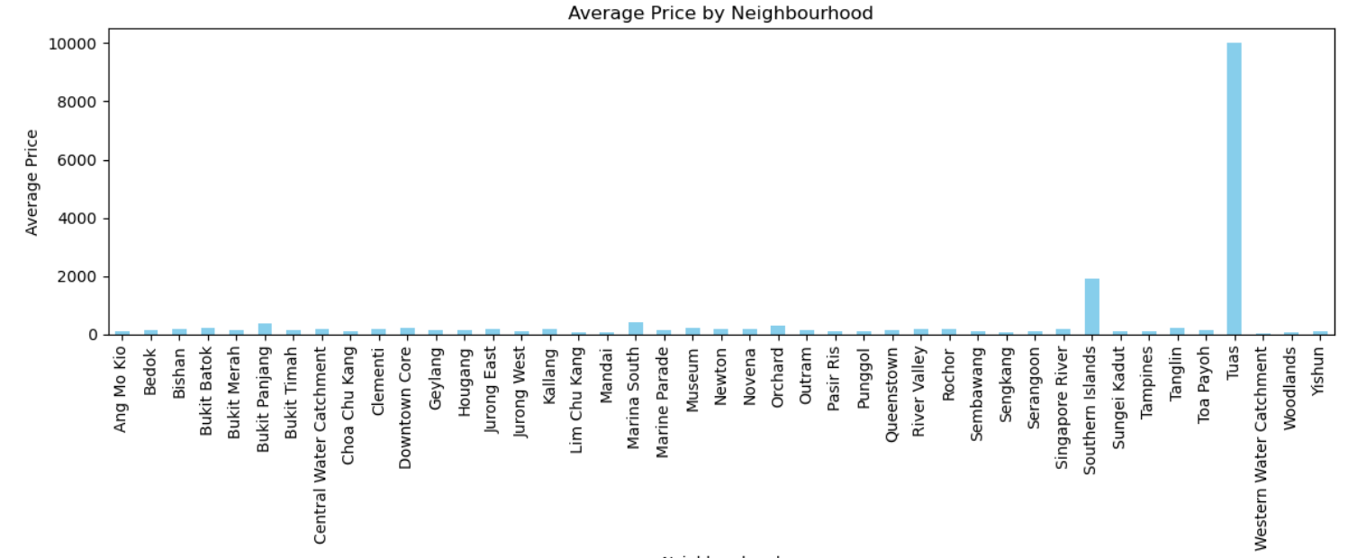

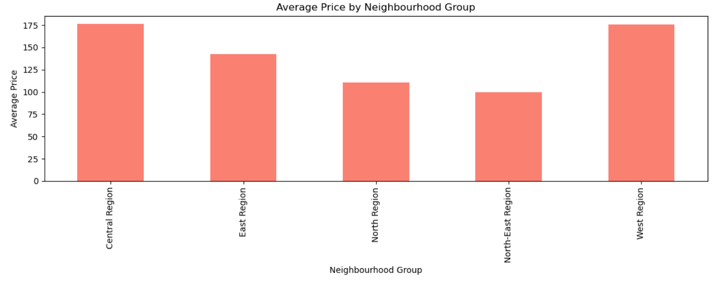

Geographical analysis of price helps both customers and hosts. Customers can plan the location of their Airbnb based on the pricing and hosts can look at the average pricing around the area and decide on a competitive pricing for their listing. The charts show that the central region and the west region are the most expensive and the north-east region is the cheapest. However, an interesting finding is that the average price for listings at Tuas is almost $10,000.

## Number of Host Listings vs Price

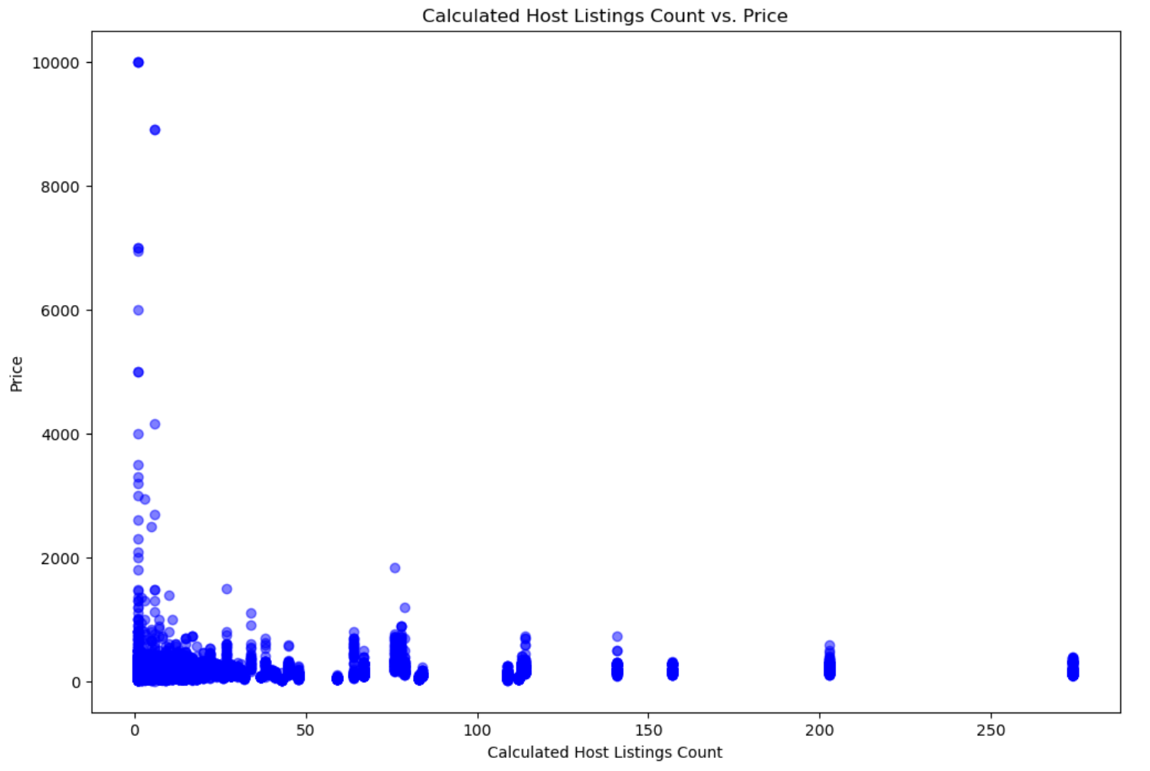

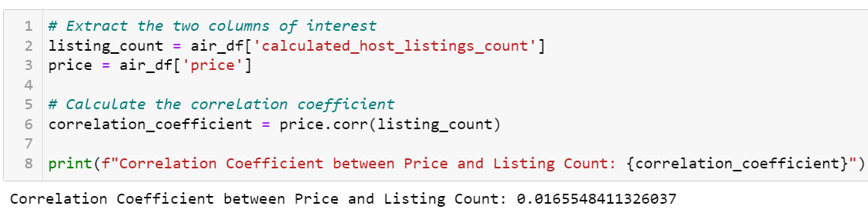

I was curious if there was a correlation between the number of listings a host had and the average price. I also wanted to find out if hosts with more listings offered higher or lower prices. The scatterplot shows that lower number of listings had a greater variety of prices but a greater number of prices tended to have prices on the lower scales. Hence, we can conclude that hosts offering lower number of listings tended to offer lower prices. Furthermore, the correlation coefficient of 0.016 shows a positive relationship in general.

## Demand vs Availability

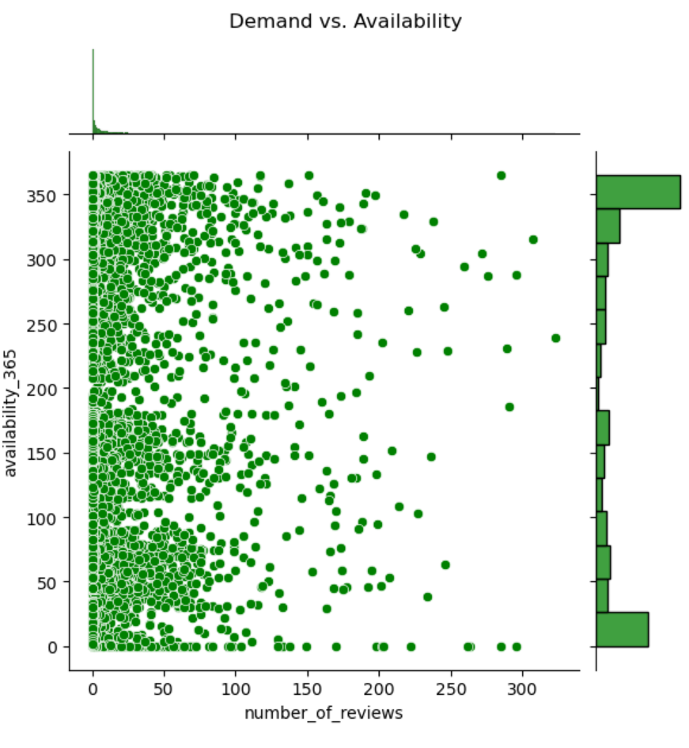

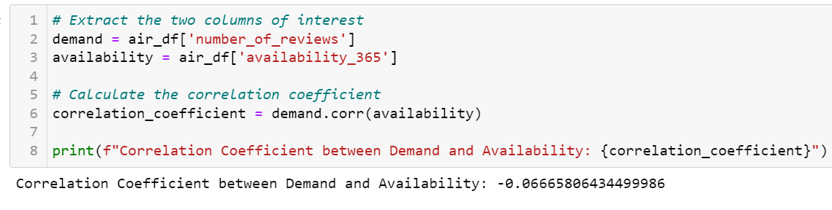

I was curious if there was a correlation if demand had any effect on the availability of listings. This can help hosts set the availability of their listings. The correlation coefficient of -0.06 shows a negative relationship in general. This can also be seen on the jointplot as there is greater availability with less demand as seen from the density bar on the y-axis.

## Data Subsetting

Now that I have a better understanding of the data and the relationships between the variables of the dataset, I can subset my dataset to build a customized price prediction model.

1. Test 1: Subsetting by Year

I tried subsetting to recent data from the recent year to ensure the model captures current market trends, adapting to dynamic factors like seasonality and external events. This enhances accuracy, aligns with real-time decision-making, and reflects the evolving nature of customer preferences and economic conditions.

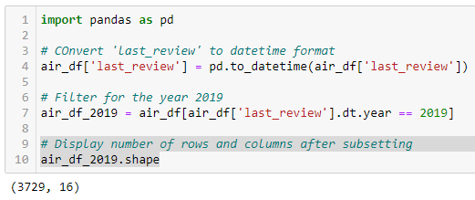

Subsetting the data to latest year 2019 caused too much decrease of rows from 7900 to only 3700 rows. Too much loss of information can reduce model prediction capabilities as it has fewer information to learn patterns from.

1. Test 2: Subsetting by Price

Subsetting to cheaper Airbnb prices is valuable for budget-conscious travelers, researchers analyzing affordability, and hosts targeting the budget segment. It offers insights into factors influencing lower-priced listings and aids tailored analyses for specific user needs.

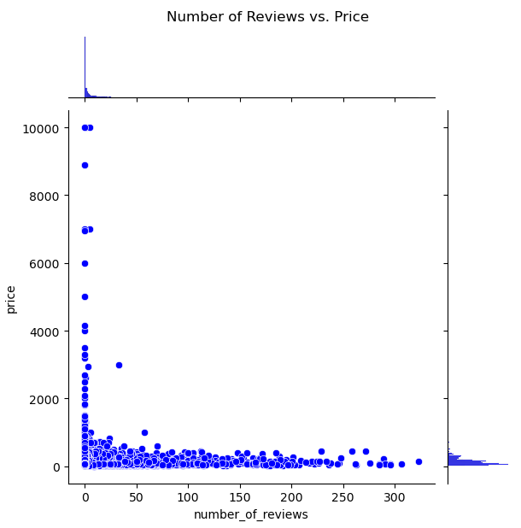

I decided to subset my data to Airbnb prices less than $600. This is because as seen from the jointplot, majority of the previous reviews are within the $600 price range, which means that most customers enjoy cheaper prices.

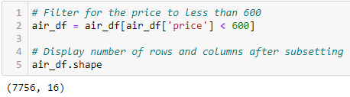

Subsetting prices less than 600 did not result in too much information loss so I found this to be the ideal subset.

## Data Cleansing

Data Cleansing must be done before data transformation as data cleansing removes missing value and changes the data type to make the variables suitable for transformation. Apart from making changes to the data, it also improves the column outside of the data such as the renaming columns.

Current Dataframe:

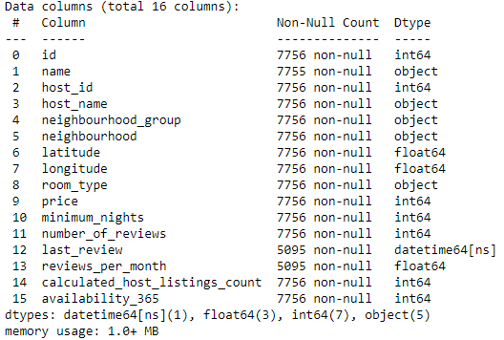

## Renaming Columns

From the above, many of the columns do not have clear names so I decided to replace them with clearer names.

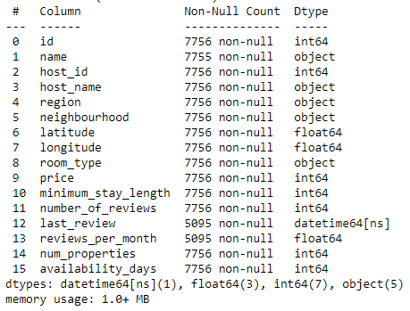

Now the dataframe has much clearer column names which are easier to understand from first glance.

## Dropping Columns

1. Unique Identifiers / High Cardinality

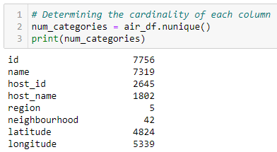

Unique identifiers such as id, host_id, name, host_name and longitude have high cardinality of more than 1000 and are generally useless for predictions because they lack predictive power and represent individual instances without inherent patterns. Encoding them later leads to overfitting, where the model memorizes the identifier rather than learning meaningful relationships in the data, compromising generalization to new instances, due to their high cardinality which might introduce biases.

1. Highly Correlated Independent Columns

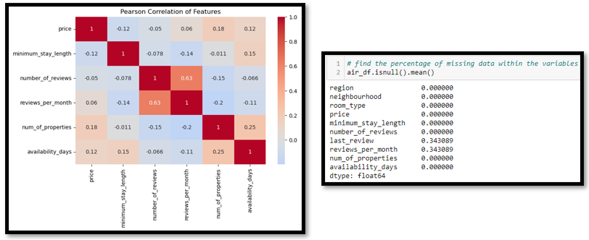

From the pearson correlation, we can see that number_of_reviews and Reviews_per_month are much more highly correlated than the rest. Having two independent variables with high correlation can introduce multicollinearity, affecting model interpretability. Removing one simplifies the model, potentially improving performance and avoiding redundancy. Since reviews_per_month had a high percentage of missing values, I decided to drop that out of the two.

1. High percentage of null values

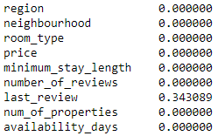

A column with a higher percentage of missing values is often dropped to maintain data integrity and prevent the introduction of bias or misinformation. Hence, I dropped last_review which had 34% missing values.

## Data Transformation

## Categorical Encoding

Categorical encoding is crucial for machine learning algorithms because many algorithms require numerical input, and categorical data is typically non-numeric. This allows algorithms to better understand and utilize these features for training models. After data cleansing, my dataframe had three categorical variables, region, neighbourhood and room_type.

1. One Hot Encoding region and neighbourhood

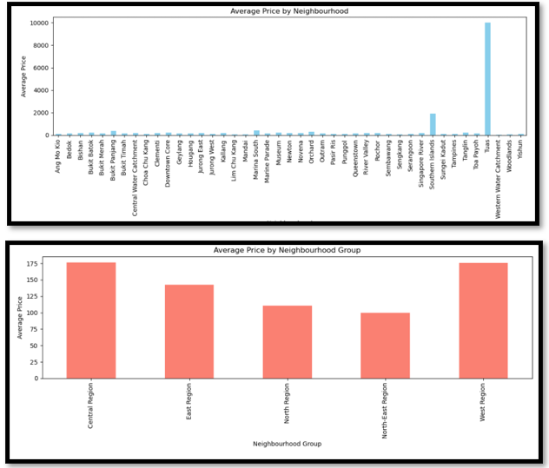

Region and neighbourhood are unordered categorical variables as there is no order across the categories. Hence, one hot encoding is used to represent each category as a binary feature, enabling machine learning models to understand and distinguish between categories without introducing any ordinal relationships that might mislead the algorithm.

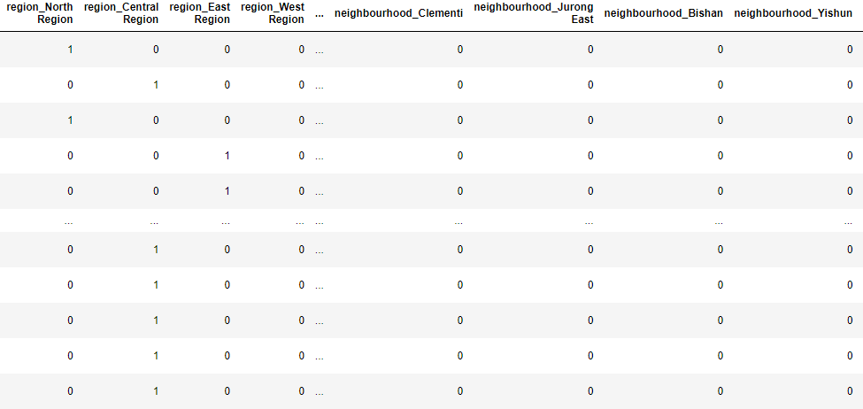

After encoding, a new column is created for each category. 1 indicates presence of that category and 0 indicates absence in that row.

1. Ordinal Encoding on room_type

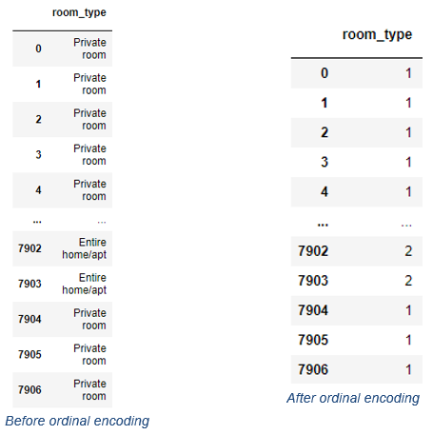

Categories in room_type follow an order in terms of size with shared room first, private room then entire home. Ordinal encoding is used for ordered categorical variables to represent the inherent order or ranking among categories, providing a numerical representation that preserves the ordinal relationships and allows machine learning models to leverage the structured nature of the data. The categories are now represented by numbers from 0 to 2 in their order i.e. private room is assigned 1 as it is the second category.

## Numerical Transformation

Numerical transformation is done on continuous numerical variables and is important to address skewness and outliers which can introduce biasness.

1. **Minimum_stay_length**

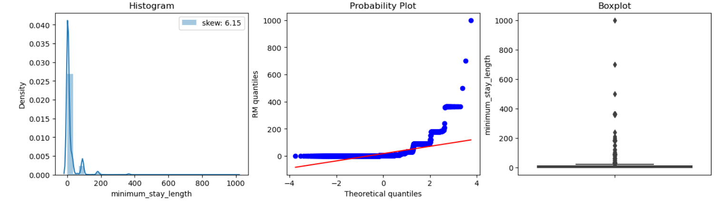

Before Box-Cox Transformation

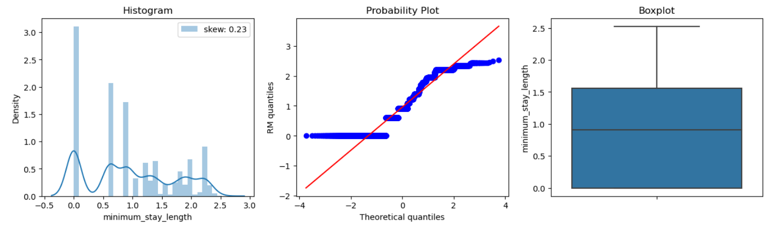

After Box-Cox Transformation

Boxcox transformation resulted in the best transformation and decreased the skewness from 6.13 to 0.23. Box-cox transformation is more suitable for positive data with varying degrees of skewness and large scales as it brings extreme high values closer to the mean. The scale was reduced from 0 to 1000 to 0 to 2.5. The variable also does not have any more outliers.

1. **Number_of_reviews**

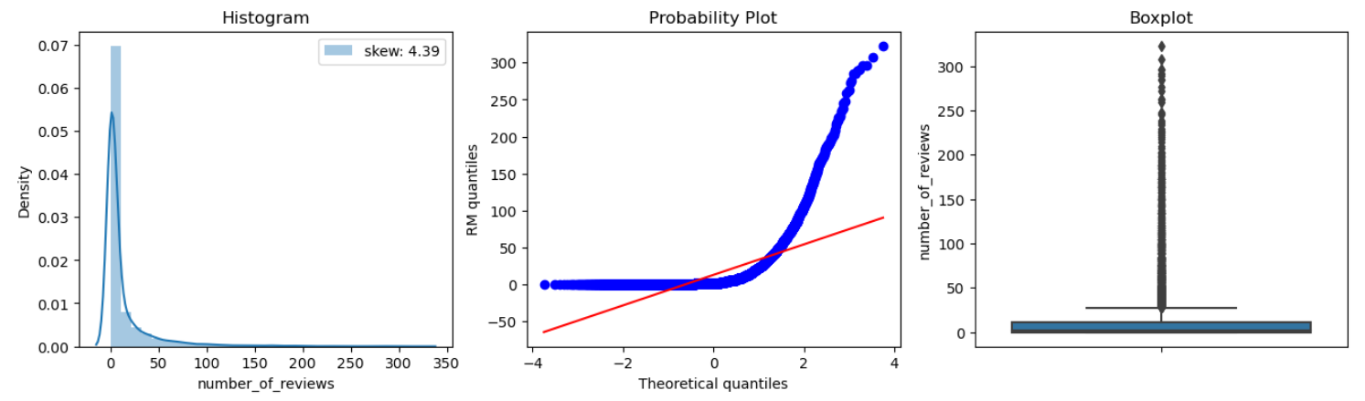

Before Yeo Johnson Transformation

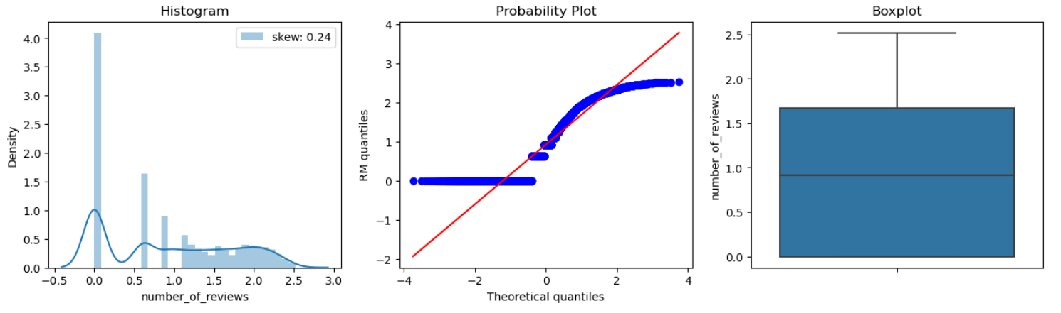

After Yeo Johnson Transformation

Yeo Johnson transformation was the best as it reduced the skewness from 4.41 to 0.24 and removed all outliers. Yeo Johnson is a generalised verison of box cox that handles all values. Hence, it was the ideal choice as the variable had 0 values and a large scale of 0 to 300.

1. **Number_of_properties**

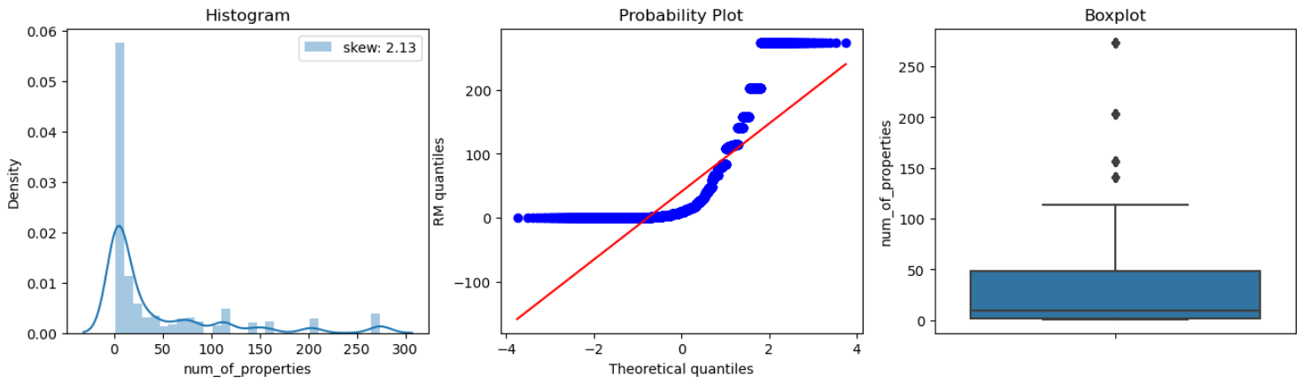

Before Yeo Johnson Transformation

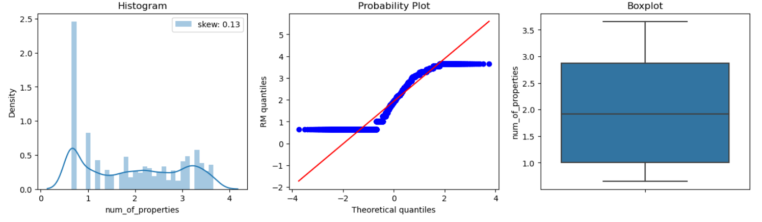

After Yeo Johnson Transformation

Yeo Johnson transformation was the best as it reduced the skewness from 2.14 to 0.13 and removed all outliers. Yeo Johnson can handle positive and negative values and automatically chooses the best power transformation based on the data, optimizing for normality and stabilization of variance.

1. **Availability_days**

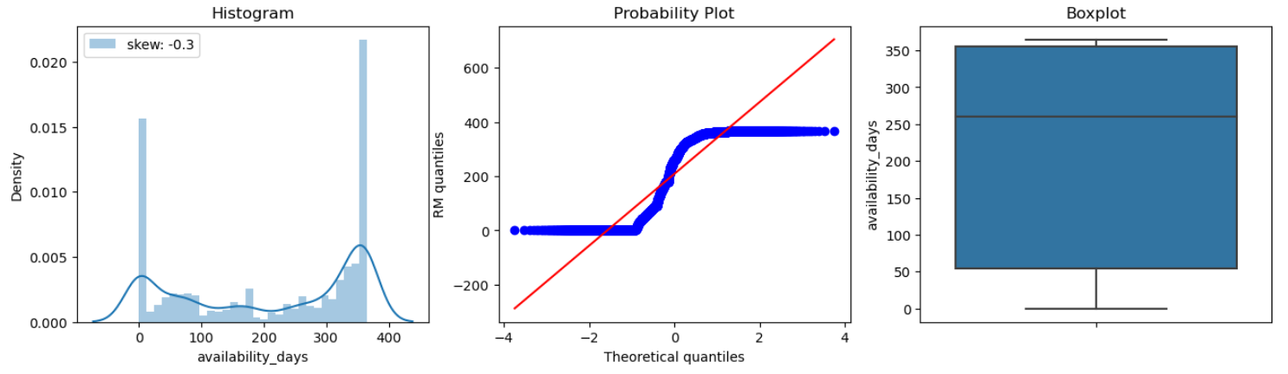

availability_days Without Transformation

Transformations did not improve availability_365 as all the transformations made distribution worse by pushing the skewness further away from 0. Without any transformation, the variable already has a little skewness of 0.3 and did not have any outliers so transformations may have overcomplicated the variable which made it worse. Hence, I decided to leave availability_days as it is.

## Scaling

Scaling is typically applied to continuous variables because it involves transforming the values of a variable to a standard scale. Continuous variables can have different ranges and units, and scaling helps ensure that all variables contribute equally to the analysis, preventing those with larger scales from dominating the others. Algorithms that are distance-based, such as k-nearest neighbors (KNN) or support vector machines with certain kernels, may benefit from feature scaling. Scaling is important for this case as the continuous variables have differing scales as availability_days has a scale from 0 to 350 while the other variables have single integer scales.

1. Mean Normalisation

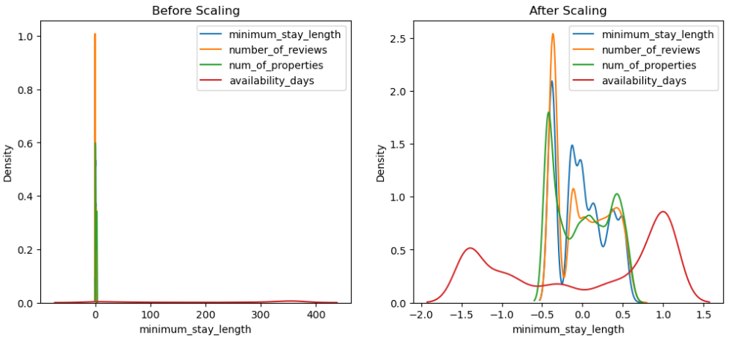

1. Min-Max Scaler

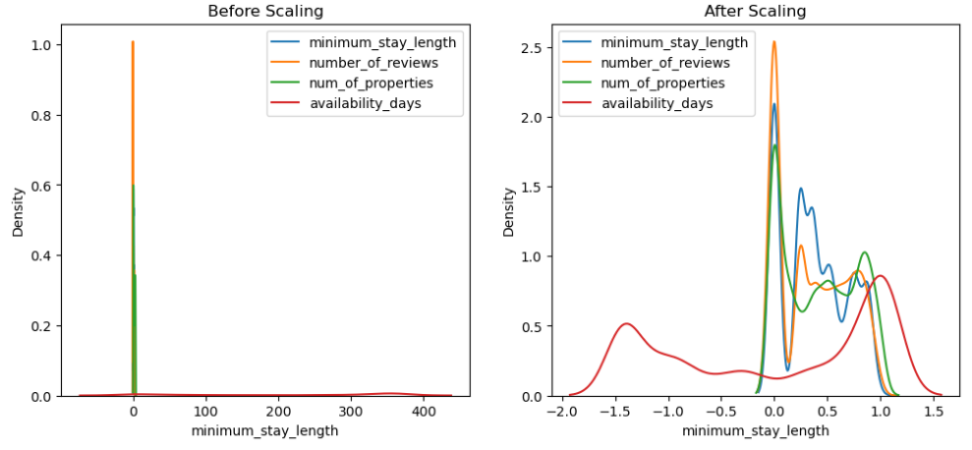

1. Maximum Absolute Scaler

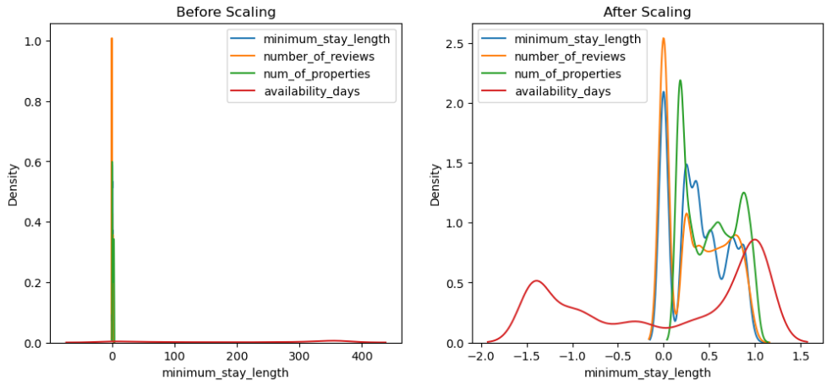

1. Robust Scaler

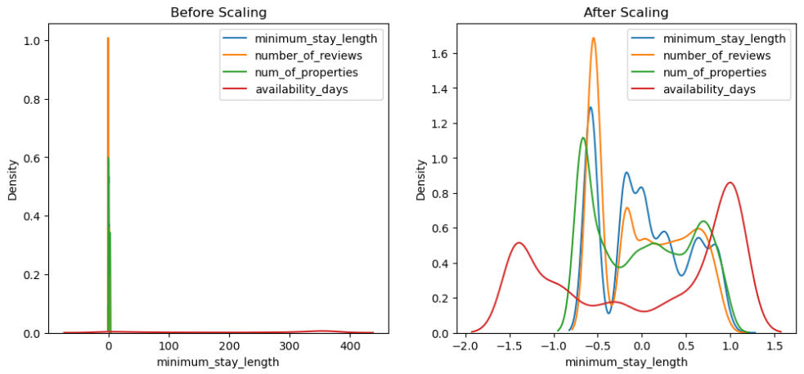

1. Standard Scaler

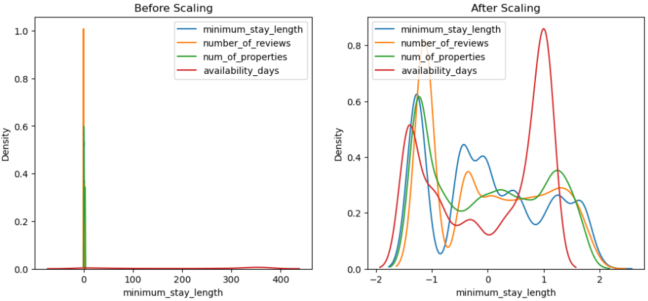

After all the scaling tests, standard Scaling turned out to be the best scaling method as the scales of the variables are the most similar after standardisation. Standardization is the process of centering the variable at zero and standardizing the variance to 1 and it preserves the original distribution of the data.

## Correlation Analysis

The purpose of correlation is to assesses relationships between variables, ensuring data quality, revealing patterns, and informing model-building decisions. I visualized a pearson correlation heatmap and conducted chi square test to see the relationship and feature importance.

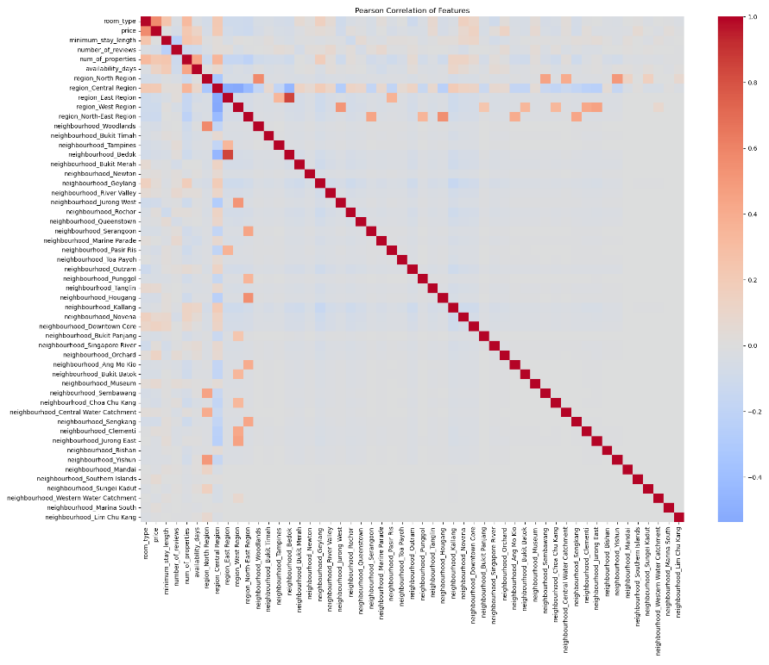

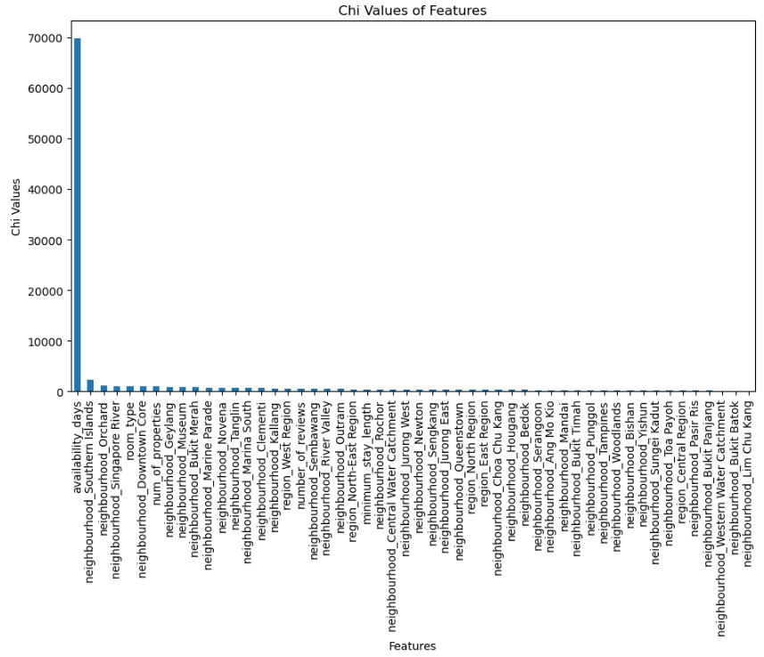

From the pearson correlation and chi square test of our dataframe, we have a better understanding of the relationship between features. Darker red show stronger positive relationships while darker blue show stronger negative relationships. The top 3 features with strongest relationship with the target are room type, number of properties and minimum stay length.

Chi square test determines the feature importance with higher chi values indicating more importance. The days the listing is considered most important in this case with a chi value around 70 000.

# Summary & Further Improvements

This will be the conclusion of the report and I will be covering the summary of my findings as I did the data exploration and data transformation of the HR analytics dataset and the Airbnb datasets. I will also further explain the future improvements that could be made to have better outcomes from the above-covered tasks.

## Summary of HR Analytics Dataset

First, I will be summarizing my findings from the binary classification problem conducted on the HR analytics dataset. In this section of the HR Analytics report, the focus was on problem understanding, data exploration, and data transformations for a binary classification problem—predicting employee promotions in an HR dataset. The goal is to distinguish accurately between employees likely to be promoted and those who aren't, providing insights for talent management and organizational growth.

Problem Understanding

The binary classification problem involves predicting employee promotions. Key features influencing promotions will be identified to aid HR decision-making.

Data Understanding

Examining data types, values, cardinality, and null values were all part of the early data investigation. The columns, ‘education’ and ‘previous_year_rating’ were found to have null values.

Univariate Analysis

Univariate analysis of categorical variables (e.g., department, region, education, gender, recruitment channel) provided insights into employee demographics, company operations, and hiring strategies. Patterns for data transformations were discovered through the analysis of continuous numerical variables (age, length of service, and average training score).

Bivariate Analysis

Bivariate analysis explored relationships between variables and the target variable (is_promoted). For categorical variables, the analysis included 'department vs is_promoted,' 'region vs is_promoted', 'education vs is_promoted', 'gender vs is_promoted' and 'recruitment channel vs is_promoted'. Discrete numerical variables ('number of trainings', 'previous year rating', 'KPIs met >80%', 'awards won?') were analyzed, as well as continuous numerical variables ('age', 'length_of_service', 'avg_training_score').

Data Cleansing

Columns were renamed ('KPIs_met >80%' and 'awards_won?'). Columns like 'employee_id', 'region,' 'gender,' and 'recruitment channel' were dropped. Missing data imputation was performed for 'previous_year_rating' and 'education.'

Data Transformation

We used categorical encoding on the terms, "education" and "department." For the numerical transformations, ‘age’, ‘avg training score’, and ‘length_of_service’, Box-Cox transformation and power transformer were used. To deal with outliers, winsorization was used. Consistent scales were guaranteed by using standard scaling.

Correlation Analysis

Pearson correlation and chi-square tests were used for correlation analysis and feature importance. The target variable ('is_promoted') had stronger relations with 'awards_won_status', 'KPIs_met_80', and 'avg_training_score'.

Handling Target Variable Class Imbalance

Stratified sampling was used to address class imbalance in the target variable, ensuring equal-sized class distribution to prevent model biasness.

## Future Improvements for HR Analytics problem

In the future, other sampling methods could have been explored to better understand their effects on the dataset. In this case of extremely imbalanced classes, other alternatives to stratified sampling could have been explored such as over sampling to increase the representation of the minority class or under sampling to reduce the representation of the majority class. Exploring more methods to handle the imbalanced classes could have allowed me to come to the best way possible to handle the imbalanced classes.

## Summary of Airbnb Dataset

In the process of preparing data for a linear regression problem predicting Airbnb rental prices, several key steps were taken, beginning with problem understanding and data exploration. The aim was to extract valuable insights, understand variable characteristics, and identify potential patterns in the dataset.

Problem Understanding:

The linear regression task involved predicting Airbnb rental prices, benefiting hosts in setting competitive prices and aiding customers in finding the best deals. Insights from key features could inform HR decisions for talent management and organizational growth.

Data Understanding:

Detailed exploration included examining data values, types, null values, and cardinality. Categorical variables like neighbourhood_group and room_type was identified, and continuous variables underwent univariate analysis, revealing distribution patterns.

Univariate Analysis:

Examining individual variables showcased insights. Categorical variables like neighbourhood_group displayed regional concentration, guiding pricing decisions. Room_type analysis highlighted a prevalence of entire homes. Numeric variables like availability_365 showed the left skewness.

Bivariate Analysis:

Understanding relationships between variables, such as Number_of_Customers vs. Price and Room_Type vs. Price, unveiled insights for revenue optimization and pricing strategy. Geographical and host-related analyses provided valuable information for targeted marketing and pricing decisions.

Data Subsetting:

Considering the large variety of samples, subsetting was explored for specialized model building. Attempts to subset by year and price were made, with the latter proving effective, focusing on Airbnb prices below $600.

Data Cleansing:

Column renaming, dropping irrelevant columns, and handling high cardinality were crucial. Identifying and addressing correlated columns and handling missing values, especially dropping last_review with a high percentage of nulls, ensured data integrity.

Data Transformation:

Categorical encoding (one-hot encoding for unordered variables and ordinal encoding for ordered variables) and numerical transformations addressed skewness and outliers. Transformations like Box-Cox and Yeo Johnson were applied to achieve more normal distributions.

Scaling:

Standard scaling ensures consistent contributions of the continuous variables to the analysis and model.

Correlation Analysis:

Pearson correlation and chi-square tests revealed relationships and feature importance. Room_type, Number_of_Properties, and Minimum_Stay_Length emerged as the variables with strongest correlations with the target variable.

## Future Improvements for Airbnb problem

Future improvements could include performing more tests on the data subsetting. A greater variety of data subsetting for a greater number of use cases could be tested to find the best use case and subset for the dataset. This can lead to better correlation and feature importance which in turn results in better model performance.